Children in the Wilderness, 2017 Tri-nations Camp
International borders have always existed as physical features which are very important for territorial sovereignty and international security, however what role do they play in conservation and the protection of wildlife, besides limiting immigration patterns of fauna?
Transfrontier Conservation is an initiative which was established to drive conservation and sustainable use of biological and cultural resources through the removal of borders in-between conservation areas thus leading to the promotion of regional peace, cooperation and socio economic development in-between the countries involved.

The Greater Mapungubwe Transfrontier Conservation was created in the year 2006 when the Memorandum of Understanding formally establishing the development of the Limpopo/Shashe Transfrontier Conservation Area was signed between Botswana, South Africa and Zimbabwe in June 2006. The name was later changed to the Greater Mapungubwe Transfrontier Conservation Area (GMTFCA). The GMTFCA was established to facilitate the conservation of biodiversity and endangered ecosystems between the three countries. Furthermore, the GMTFCA was perceived as a vehicle for the promotion of regional peace and stability, economic development and the preservation of the vast culture and heritage of the GMTFCA, a culture and history which still remains a mystery to many till today. From the archaeological sites found within the area which indicate that civilisation thrived as a sophisticated trading centre of the largest known kingdom in southern Africa, to the gold artefacts found and remnants of dwellings found in the area, which suggest that the civilians at that time were well equipped with multiple skillsets.

The Children in the Wilderness (CITW) is a non- profit organisation that has been in existence since 2001. Due to the fact that it’s a non-profit organisation consistent fundraising is always going to be a key factor in ensuring the sustainability of the programme among African communities.

The annual Tri-nations Camp was held on the 11th- 15th of December 2017, at the Mapungubwe National Park Auditorium and Confluence Viewpoint in the Limpopo Province. The national Department of Environmental Affairs facilitates the cross border events such as Tour de Tuli and Tri-nations in conjunction with Children in the Wilderness organisers.

CITW organized the camp in an aim to create a network of learning centres that uplifts children in rural areas through educational programs that put conservation at the forefront, so as to develop environmental leaders/ambassadors who are inspired to care for their heritage and environment to ensure they become custodians of their area in the future. Furthermore the Tri-nation Camp exposes children to their wildlife heritage, builds and strengthens their capabilities to cope with life challenges and educates them with the life skills necessary to actualise their greatest potential.

The children hosted at the camp are rural children that live adjacent to the GMTFCA and on a bi-annual basis the camp hosts twenty-four children and eight teachers from Botswana, South Africa and Zimbabwe respectively.

The 2017 camp consisted of 18 children and 12 eco mentors, who facilitated the activities and educated the pupils throughout the five day course. Lessons on Biodiversity, the food chain, Transfrontier Conservation areas (TFCAs) and a lesson on how to build and operate a tippy tappy, a device which conserves water and ensures children are aware of personal hygiene were provided throughout the five day course. Besides the activities the children were also granted the opportunity to go on a game drive and to visit the Mapungubwe museum were they learnt about the great history of the Mapungubwe area and its people.
Not only did the camp educate the pupils about conservation and a host of other careers it also gave them an opportunity to network with one another and create friendships as well as widen their scope of their view of life.
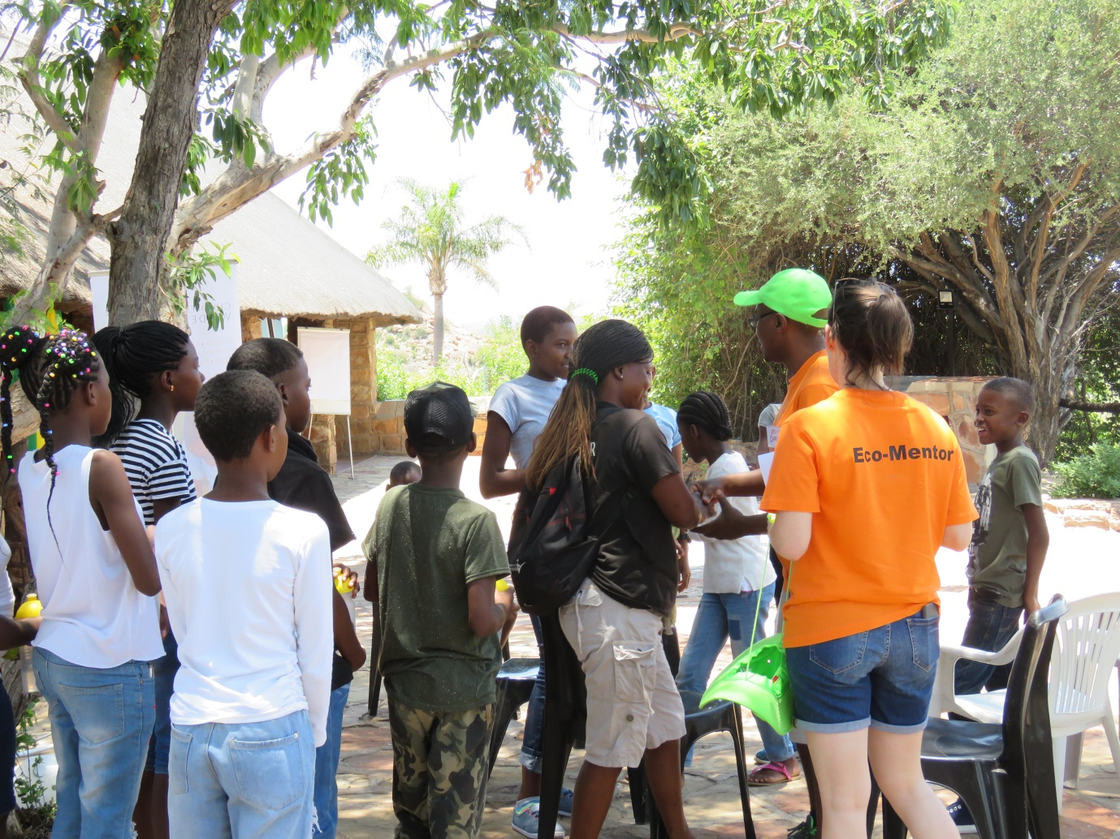
Figure 1: Tri-nation Campers being welcomed by their mentors

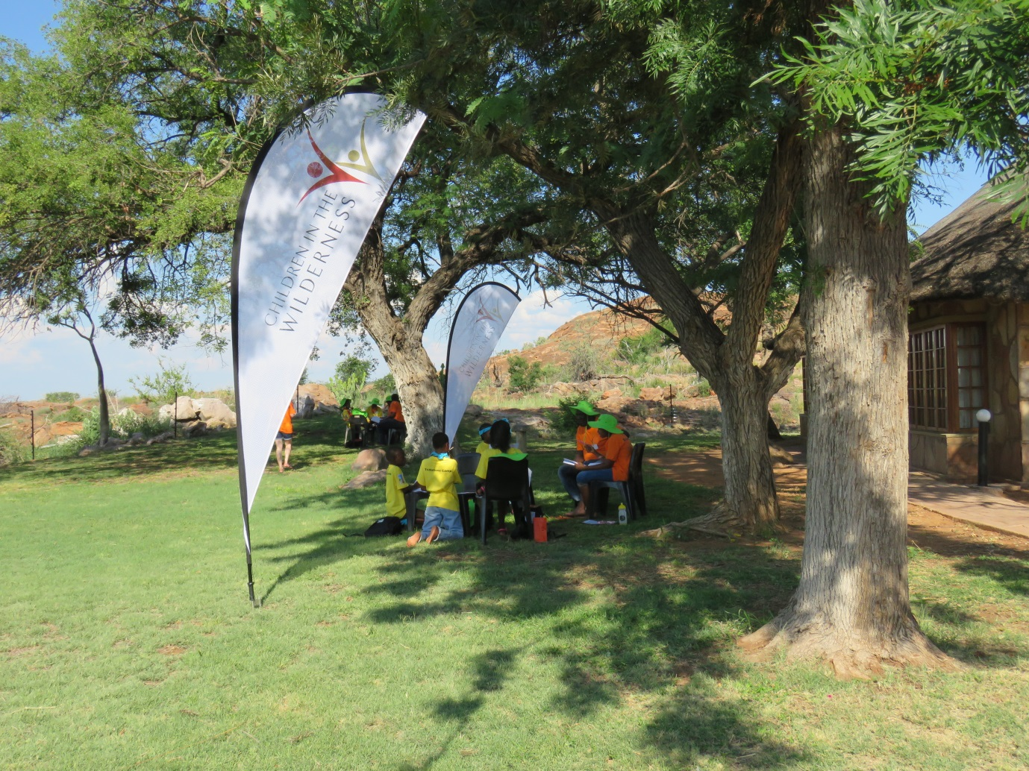
Figure 2: Campers being put through one of their lessons in conservation
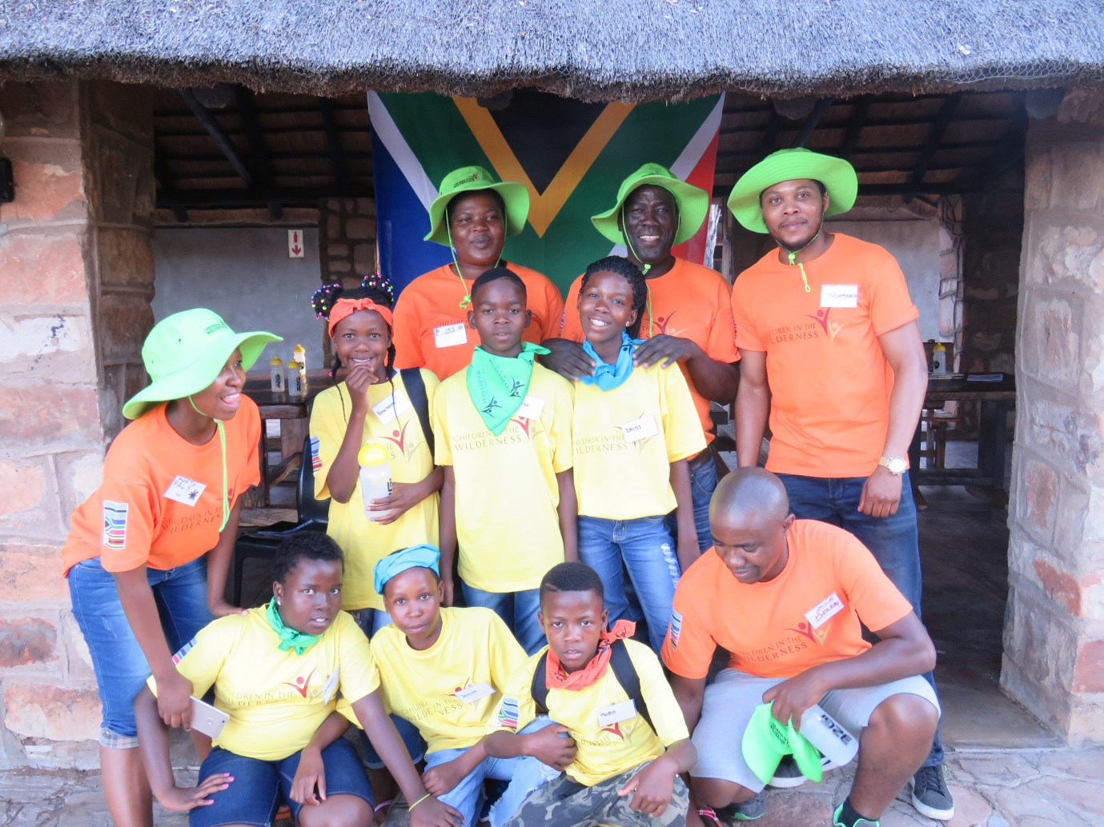
Figure 3: Tri- Nation’s campers from the South African Side
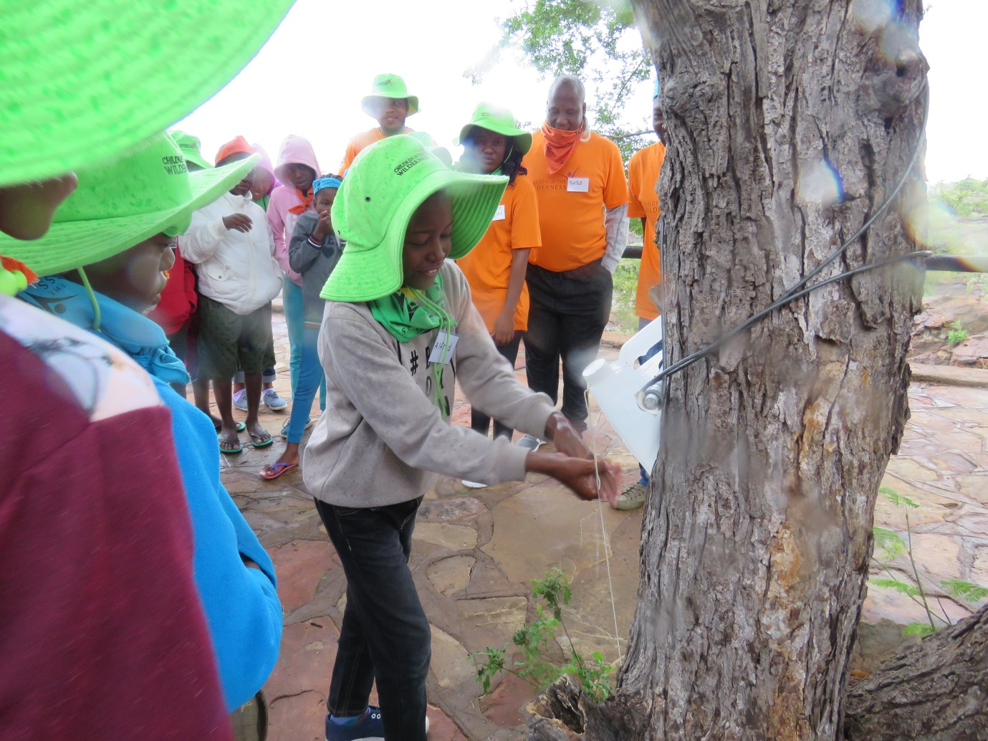
Figure 4: Tri-Nations Campers being taught how to construct and use a Tippy Tappy

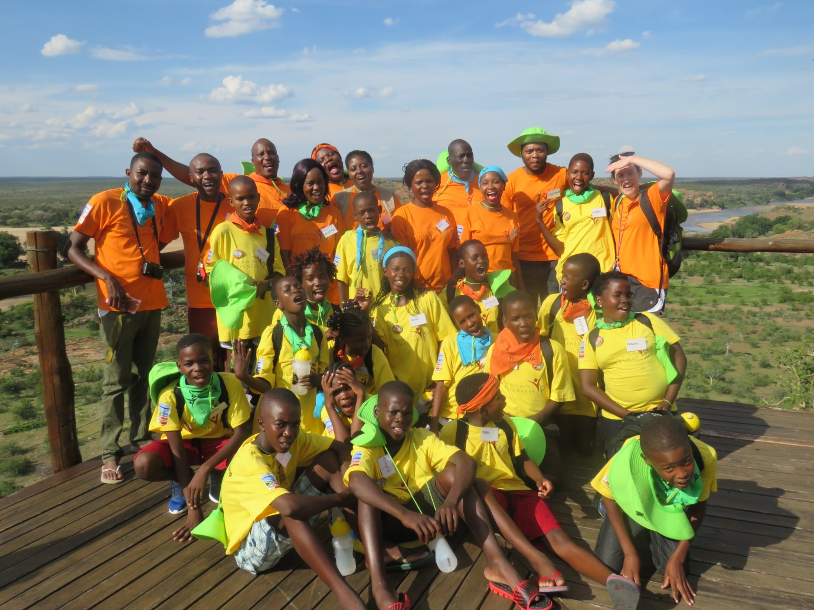
Figure 5: Tri-Nation Campers Group photo at the confluence

