The Khetha Program, a joint USAID and WWF SA initiative in South Africa and Mozambique aimed at reducing the impact of illegal wildlife trade in rhinos and elephants in the Great Limpopo Transfrontier Conservation Area (GLTFCA), built successful foundations in 2018.
Khetha delivers strong institutional relationships and lays the groundwork to improve wildlife trafficking enforcement and test community-based conservation approaches to high value wildlife trade
Between September 2017 and October 2019, Khetha made significant progress in securing relationships with key institutional stakeholders in South Africa and Mozambique, including South African National Parks (SANParks), the South African Department of Environmental Affairs (DEA), the Mozambique Attorney General’s Office (PGR), the Mozambican National Administration for Conservation Areas (ANAC) and the Joint Management Board of the Great Limpopo Transfrontier Conservation Area (GLTFCA). These relationships have resulted in MoUs between Khetha and both SANParks and DEA, and endorsement by ANAC and PGR to work in the Mozambican landscape from district to national level.
Understanding community sentiment towards wildlife and protected areas
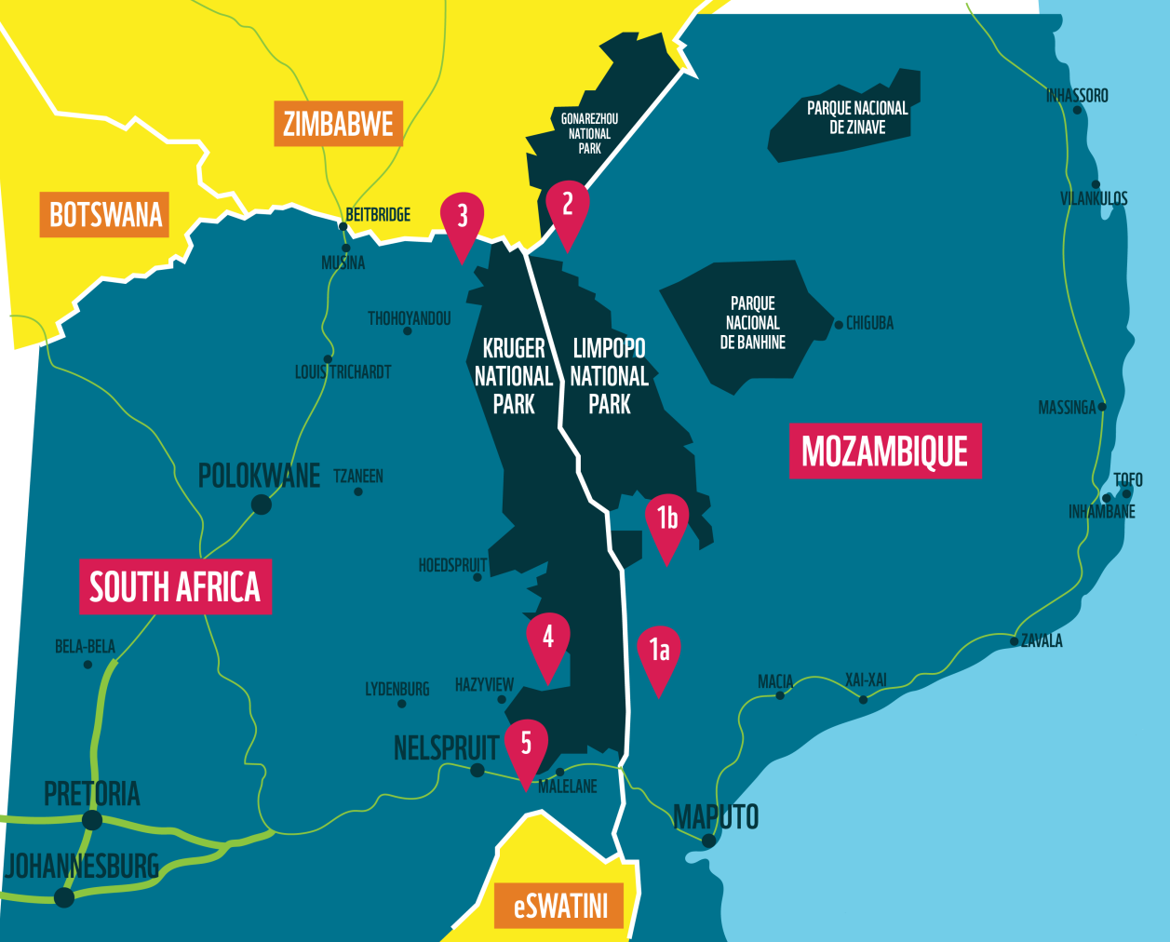
Khetha identified six geographical focus areas (nodes) where community-based approaches to improve the relationship between people and wildlife will be tested. Our team / partners are currently engaging stakeholders in the Sabi River and Matsulu Corridor nodes to prepare for baseline research on community attitudes and perspectives towards wildlife, protected areas and the illegal wildlife trade. The research will help us understand the sentiments and perceptions that drive illegal wildlife trade and the dynamics that underpin the relationship between communities and protected areas. Khetha is also piloting a cutting-edge qualitative data collection and program design tool, SenseMaker, to support this work.
Figure 1: The Khetha nodes in the GLTFCA
These are the nodes illustrated in Figure 1 above:
(1a) Greater Lebombo Conservancy (GLC), located in the Moamba district of Maputo Province,
Mozambique.
(1b) Greater Lebombo Conservany (GLC), located in the Magude District of Maputo Province and in the Massingir District of Gaza Province, Mozambique.
(2) Pafuri Node Mozambique, located in Chicualacuala District of Gaza Province in Mozambique.
(3) Makuya Node, located in the Vhembe District of the Limpopo province, South Africa.
(4) Sabie River Node, located in the Ehlanzeni District of the Mpumalanga Province, bordering the
Sabie River, South Africa.
(5) Matsulu Corridor Node, located in Ehlanzeni District of Mpumalanga Province, South Africa.

Strengthening wildlife trafficking law enforcement at South Africa’s borders
Khetha’s efforts to support law enforcement agencies in both countries to prevent, detect, investigate and prosecute wildlife trafficking have been initiated through support to DEA in issuing a range of training and guidance documents for law enforcement officials who would be exposed to wildlife trafficking incidents while on duty.
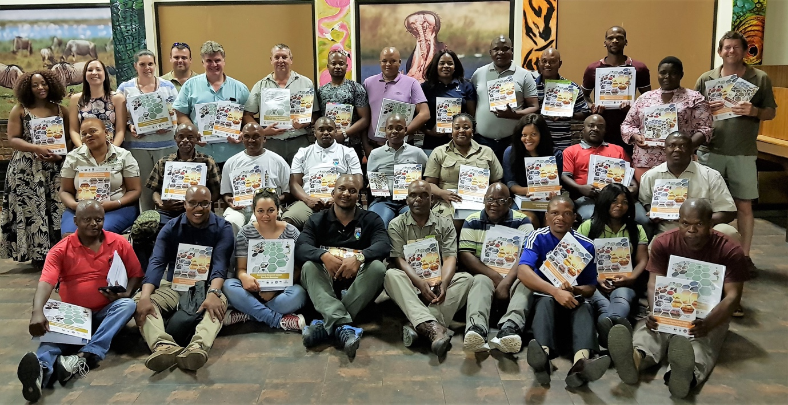
Figure 2: EMI training group photo
Wildlife photography improves attitudes towards wildlife

Khetha, in partnership with Wildshots Outreach, provided wildlife photography training to eight young, unemployed men and women from Islington, close to the Kruger National Park. The aim of the training was to build marketable technical skills while also fostering an appreciation for wildlife. While the participants live only a few kilometres from the closest protected area, most had never been inside a park. The students attended four workshops after which they tested their new skills during a wildlife photography drive in Thornybush Private Reserve. All participants received a certificate of achievement after the training. This work supports our efforts to build bridges between local communities and protected areas.
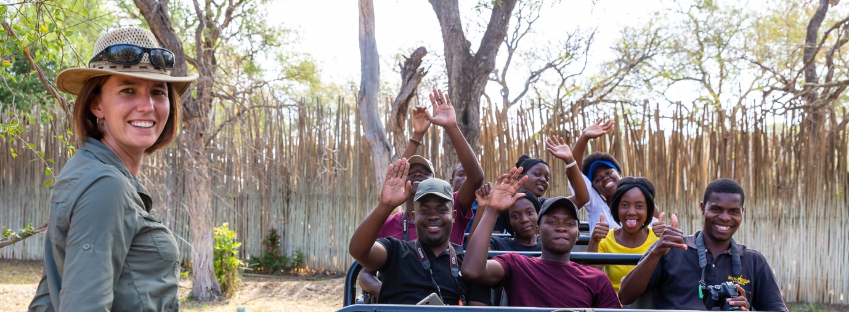
Figure 3: Wildife photography course
Other work includes:

- understanding wildlife poisoning in the Great Limpopo Transfrontier Park (GLTP);
- developing a GLTFCA Elephant Management Framework;
- testing restorative justice as an approach to prevent wildlife trafficking;
- analysing the value of situational crime prevent approaches in addressing wildlife trafficking.
- assessing situational wildlife crime prevention approaches founded on conservation criminology principles;
- developing ranger leadership skills with the Southern African Wildlife College;
- developing guidelines and multimedia training curriculum in so far proper management, processing and investigation of wildlife trafficking related crime scenes found within the port environment;
- developing Elephant and rhinoceros poaching crime scenes guidelines and training curriculum.

