2015 Tour de Tuli annual cycling event and Tri-Nation Eco-camp.
The eleventh Nedbank Tour de Tuli Annual Cycling Event took place from 13 to 18 August 2015 at Greater Mapungubwe Transfrontier Conservation Area (GMTFCA). The route traversed areas of the GMTFCA including Botswana, South Africa and Zimbabwe. The tour was meant to achieve the following objectives: Create a wonderful cycling adventure for cyclists; raise awareness about GMTFCA and the beautiful wilderness areas together with community land through which the tour traversed; development of skills and training of local community members and staff as well as raising funds for educational camp for selected children neighboring the TFCA.
Children in the Wilderness (CITW) in conjunction with other partners, including the TFCA Directorate of the Department of Environmental Affairs hosted the event. Cooperation and support from various government departments of the partner countries ensured that the event becomes a success. The event contributed immensely to the economy of the partner countries through purchasing of goodies locally, use of local labor, over- border payments, fuel and drinks.
The 2015 route covered approximately 280km of mountain biking tracks over four days, covering three countries. The tour attracted many top South African business leaders and many international participants from as far as Australia, Canada, Germany and the USA. 289 cyclists took part in the event with 41 cyclist leaders, 63 volunteers and 97 paid staff members. Four development riders joined the cyclists, together with TFCA Director Mr. Ernest Mokganedi who managed to finish the entire tour. Mr. Mokganedi said “the experience was fulfilling and the excitement among cyclists from different countries was encouraging”
Proceeds from Tour de Tuli cycling event were used to set up tri-nations eco camp for children neighbouring GMTFCA. Children were chosen from the three countries involved in the GMTFCA, namely Botswana, South Africa and Zimbabwe. The camp was held from the 07th to the 10th of December 2015 on the RSA side of the GMTFCA. It focussed on environmental learning, various life skills activities, including focus on careers in tourism and conservation. It is an environmental and life skills educational programme that focuses on the next generation of rural decision makers. The camp hosted twenty four children and eight teachers from Botswana, South Africa and Zimbabwe.
The programme aims to develop environmental leaders/ambassadors who are inspired to care for their heritage and environment to ensure they become custodians of their area in the future. The camp displayed cooperation from various agencies involved in TFCAs activities such as Agriculture, Defence, Health, Immigration and Police in ensuring that there is smooth crossing over of children into GMTFCA. Ms Cynthia Skommere (TFCA Directorate) who was part of the eco-mentors said “the camp was a good initiative to give back to local communities and also helped in raising awareness of the TFCA. It played an important role in ensuring interaction among the kids and information sharing, particularly because they came from different backgrounds”.
Children learning about plants through demonstration
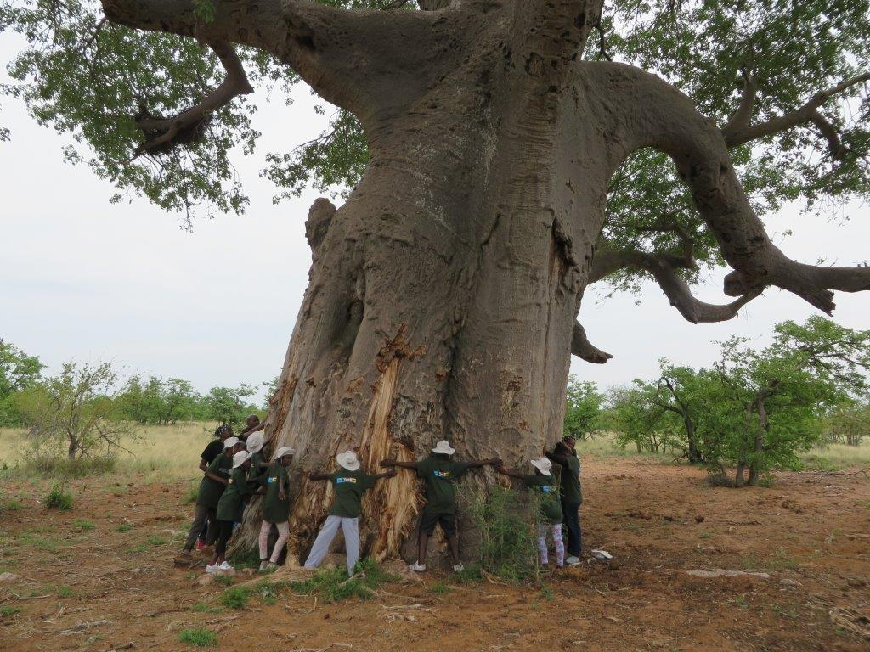

Eco-mentor teaching kids about heritage issues at Mapungubwe auditorium
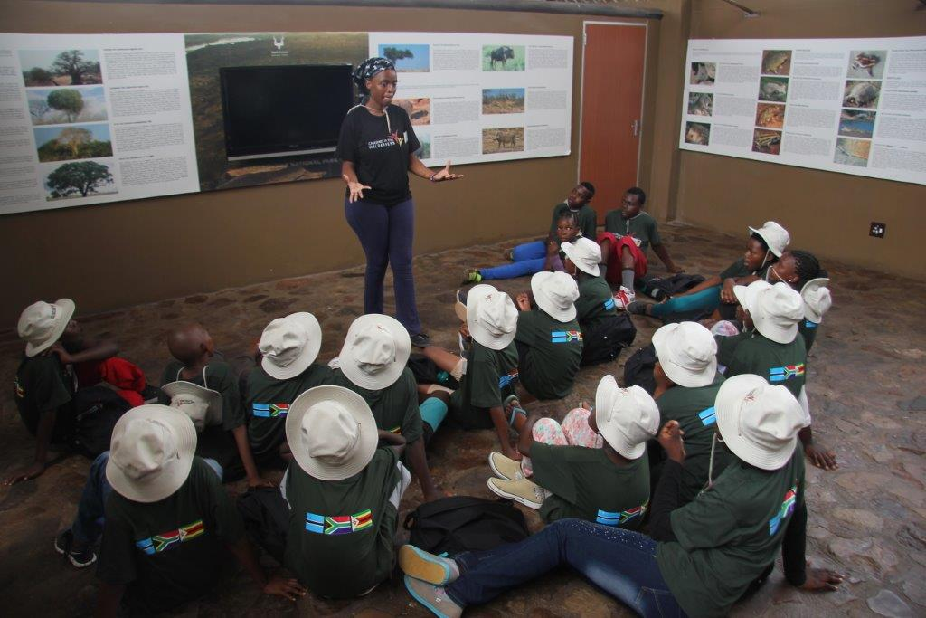
Learners getting their reward (swimming) for performing well 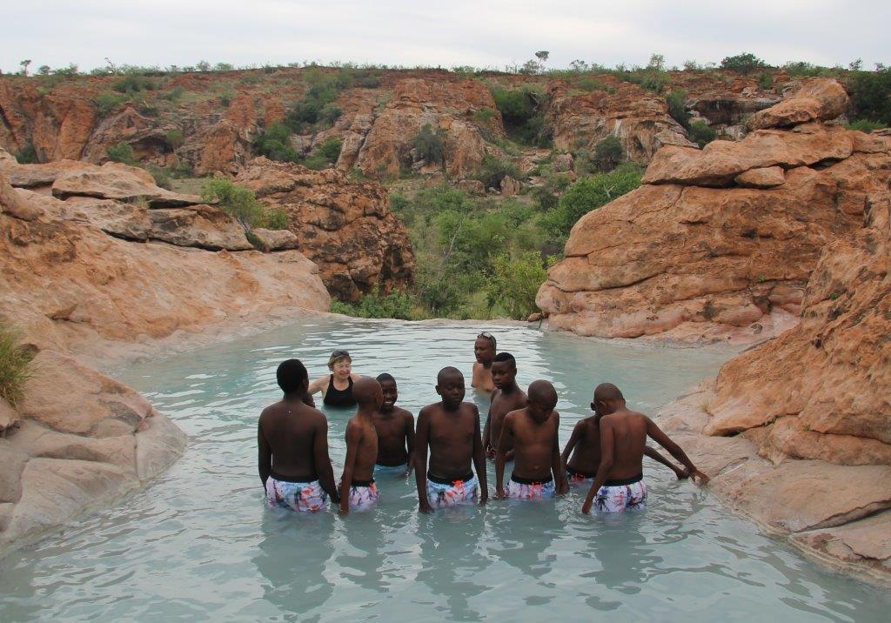

Cyclists enjoying the wilderness area of the GMTFCA
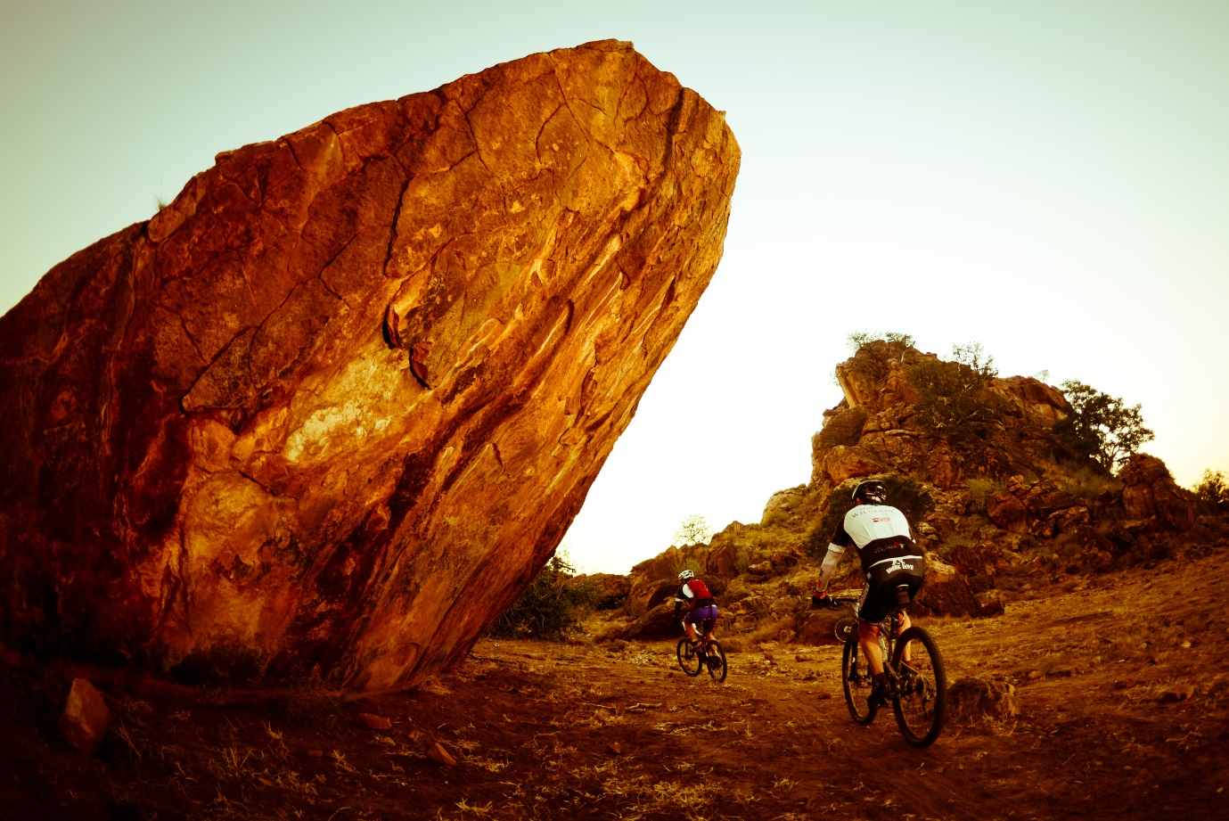

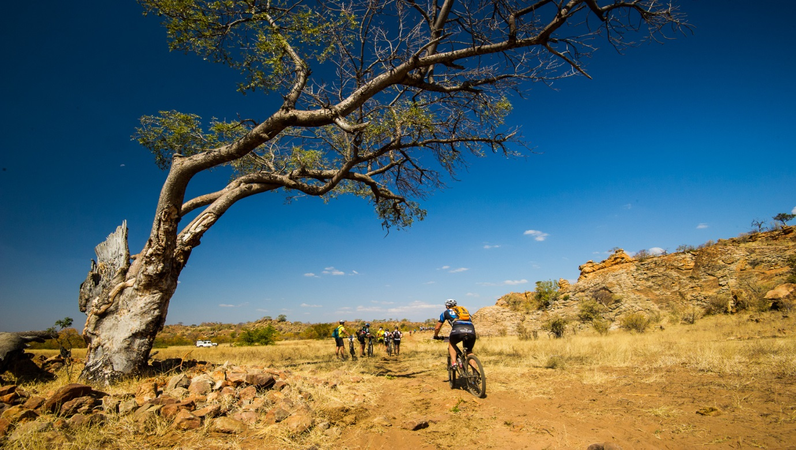

Cyclists crossing Limpopo River under protection from field rangers
