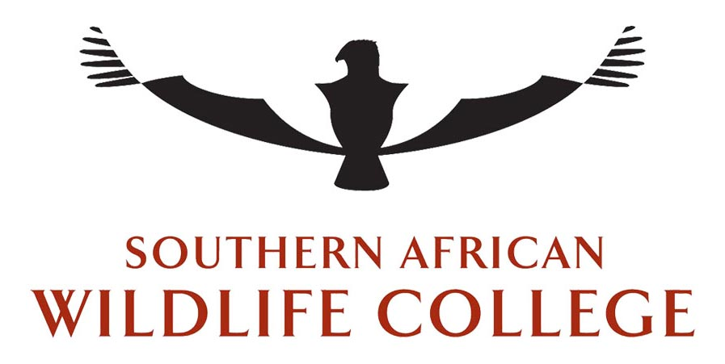

Registered as a Non-Profit Company of the Companies Act of 2008
Registration Number 1996/005726/08. 046-675-NPO. 930016093-PBO

DEVELOPMENT AND IMPLEMENTATION OF CROSS-BORDER MOBILE TRAININGS IN SIX SADC TFCAs’
SHORT REPORT – NOVEMBER 2014
Department of Innovation & Development
Southern African Wildlife College
Alan Gardiner & Marilize Van der Walt

Directors: Dr. I.B. Mkhize (Chairman), Mr. I. Goodwin, Countess. S. Labia, Mrs. L.M. Lynch, Mr. M. Mnisi,
Mr. O.E. Mokganedi, Mr. W. Myburgh, Dr. G. Raven, Prof. B.K. Reilly, Dr. B. Soto (Mozambique), Mrs. T. Sowry.
Private Bag X3015, Hoedspruit 1380, South Africa Telephone: +27 (015) 793 7300 Fax: +27 (015) 793 7314 e-mail: info@sawc.org.za www.wildlifecollege.org.za
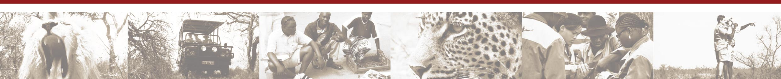
Provisionally registered with Department of Education as a private FET College until 31 Dec 2014 Reg. No. 2008/FE08/003
Provisionally registered as a Private Provider of Higher Education. Accreditation Number: 2011/HE08/004

Table of Contents
SUMMARY 3
INTRODUCTION 4
APPROACH 4
FINANCE 6
TRAINING 7
- Greater Mapungubwe Transfrontier Conservation Area 7
Participants 8
Outcomes 9
- Greater Limpopo Transfrontier Conservation Area 12
Participants 12
Outcomes 14
- Lubombo Transfrontier Conservation Area 15
Participants 16
Outcomes 18
- Maluti Drakensberg Transfrontier Conservation Area 21
Participants 21
Outcomes 23
- Chimanimani Transfrontier Conservation Area 25
Background Information for Chimanimani National Park 25
Participants 26
Outcomes 28
- Nyika Transfrontier Conservation Area 31
Training 32
Participants 32
Outcomes 33
CBNRM challenges in Nyika TFCA 36
TRAINEE FEEDBACK 39
ADVANTAGES, DISADVANTAGES AND THE FUTURE OF CROSS BORDER MOBILE TRAINING 40
CONCLUSION AND RECOMMENDATIONS 42
ACKNOWLEDGEMENTS 43

Summary

Cross border training took place at six TFCAs’ within the SDAC region: Chimanimani (Mozambique & Zimbabwe), Greater Limpopo (Mozambique, South Africa & Zimbabwe), Greater Mapungubwe (Botswana, South Africa & Zimbabwe), Lubombo (Mozambique, South Africa & Swaziland), Maluti-Drakensberg (Lesotho & South Africa) and Nyika (Malawi & Zambia). A training needs analysis was first carried out for each TFCA. Although there was often more than one training need at a TFCA the subject(s) chosen for a TFCA was the one(s) considered of most importance by the TFCA. A mobile training unit was then taken to the TFCA and 5 days of training took place within the TFCA. The subjects were taught in a collaborative manner with the actual concerns of the TFCA incorporated into the training so as to be applicable to the TFCA.

The success of the training can be shown by the on the ground changes and increased collaboration, taking place within the TFCA’s. Although a great deal more collaboration, negotiation & training is required at all levels of the TFCA’s the focus of training should be targeted at those carrying out on the ground operations within the TFCA. At the higher levels there is still need for negotiation between or amongst the countries. These negotiations should be targeting cross border collaboration and encouraging bottom-up process’s to take place.

Introduction

From an ecological and biological perspective the TFCA concept has many positive arguments. These arguments gave momentum to the initial development and implementation of the concept. A number of the TFCA’s were formed more than 10 years ago, and yet on the ground developments to back these arguments have been slow. With this in mind GIZ proposed:

“In order for TFCA’s to improve the effectiveness of conservation, compatible management of shared ecosystems is necessary”. From this came their objective:

“To increase the collaboration amongst stakeholders of TFCA’s through subjects that will improve the functioning and purpose of the TFCA.”

Funding was provided by GIZ to SAWC for training which would attempt to start the process of fulfilling this objective. After discussions it was decided the most effective way of training was to let the training take place at the TFCA’s rather than bringing members from the various TFCA’s to an external training site. The training was planned so the SAWC mobile training unit would go to each TFCA. This type of training requires more logistic effort but is likely to show more positive trends in the long term.

Approach

It was originally proposed by SADC that training take place in 12 TFCA’s. But when the budget and effectiveness of training were taken into account, especially with mobile units, it became clear that a smaller number of TFCA’s should be selected. It was finally agreed upon that training would take place in 6 TFCA’s (Table 1.). A training needs analysis was then carried out for the 6 selected TFCA’s. As the budget for this training was limited, we combined this TNA with other projects being carried out in some of the TFCA’s and hence each TFCA area, except the GLTFCA into which the College falls, was visited and the TNA completed (with the help of RESILIM co-funding).
Once subjects had been identified for each TFCA a time schedule and logistics were organized. The training took place on site at each of the concerned TFCA’s. This was done by firstly identifying a suitable location for the training within the TFCA. From this the logistics of getting the trainees to the site, especially those from the neighbouring country(s) was undertaken. When possible catering was sourced from the training area, although the College has a mobile catering team, this approach was taken as it was felt some of the funds would be interjected into small business’s within the TFCA. It however does mean one has less control on the catering product.

Having the training take place at the TFCA meant that real needs and problems surfaced rapidly and could be incorporated into the training. A strategy for the implementation of the training outcomes was discussed for the workplace. With this type of training it is hoped the knowledge imparted will be taken on board in a long term manner thus improving the collaboration among the stakeholders. At each training workshop, no matter what the training subject, cross border communication and linkages were discussed and put in place. This was very affective as contact people could be decided there and then.

When law enforcement was chosen by the TFCA as a training need, this resulted in a bias towards male attendees. This should be put in perspective with other training taking place in TFCA’s, for instance, during Green Economy training, through the RESILIM project, in the greater Mapungubwe TFCA nearly all 60 attendees were female.

Table 1. The six TFCA’s selected for training
Trans Frontier Conservation Area | Abbreviation | Countries
Greater Mapungubwe TFCA | GMTFCA | Botswana, South Africa, Zimbabwe
Greater Limpopo TFCA | GLTFCA | Mozambique, South Africa, Zimbabwe
Lubombo TFCA’s |  | Mozambique, South Africa, Swaziland
Maluti-Drakensberg | MDTFCA | Lesotho, South Africa
Chimanimani TFCA |  | Mozambique, Zimbabwe
Nyika TFCA |  | Malawi, Zambia

Finance

The financial summary of the project is provided below. The coordination of the project was slightly over budgeted while the trainer travel was slightly under budgeted by a similar amount. On average 5 days of training at a TFCA cost R155 000 or R11 488 per person (approximately US1 000/person).
INCOME
Contract Value |  | 930 510.01
EXPENSES
 |  | APPROVED BUDGET |  | ACTUAL EXPENDITURE |  | VARIANCE
Planning |  | 291 480.00 |  | 288 208.73 |  | 3 271.27
 | Travel to Gaborone | 60 000.00 |  | 59 999.96 |  | 0.04
 | Needs Specification | 31 200.00 |  | 31 201.52 |  | -1.52
 | Administration & Finance | 42 000.00 |  | 43 731.75 |  | -1 731.75
 | Coordination | 75 000.00 |  | 69 995.50 |  | 5 004.50
 | Monitoring & Evaluation | 53 280.00 |  | 53 280.00 |  | -
 | Reporting | 30 000.00 |  | 30 000.00 |  | -
Training |  | 278 700.00 |  | 284 287.14 |  | -5 587.14
 | Trainer travel to site | 60 000.00 |  | 65 747.18 |  | -5 747.18
 | Administration during training | 30 000.00 |  | 29 999.97 |  | 0.03
 | Training facilitating | 150 000.00 |  | 149 874.05 |  | 125.95
 | Interpreter onsite support | 25 920.00 |  | 25 885.94 |  | 34.06
 | Guide and Field trips | 12 780.00 |  | 12 780.00 |  | -
Training materials |  | 103 290.00 |  | 103 277.50 |  | 12.50
 | Material production | 8 400.00 |  | 8 387.50 |  | 12.50
 | Training consumables | 10 440.00 |  | 10 440.00 |  | -
 | Certification | 7 200.00 |  | 7 200.00 |  | -
 | Office running costs | 2 250.00 |  | 2 250.00 |  | -
 | Material development | 75 000.00 |  | 75 000.00 |  | -
Venue, Accommodation, Catering |  | 257 040.00 |  | 254 736.64 |  | 2 303.36
 | Accommodation | 206 640.00 |  | 172 707.22 |  | 33 932.78
 | Catering | 50 400.00 |  | 82 029.42 |  | -31 29.42
 | TOTAL | 930 510.00 |  | 930 510.01 |  | -0.01

Training

Greater Mapungubwe Transfrontier Conservation Area

Coordination: Ms. Marilize van der Walt
Course Evaluation: Dr. Alan Gardiner, Dr. Hannah Barnes and Mr. Ruben de Kock

Mapungubwe Transfrontier Conservation area is a world renowned archaeological, cultural, and impressive scenic area located in the confluence between the Limpopo and Shashe Rivers. This historical area with world heritage boasts a rich faunal diversity and expansive savannah landscape. The three countries (South Africa, Botswana and Zimbabwe) encompass the GMTFCA. The conservation area which make up the TFCA are Mapungubwe National Park and World Heritage site (South Africa), Tuli Circle Safari, Maramani communal land, Machachut, Masera River Ranch & Maepa hill (Zimbabwe), and Northern Tuli Game Reserve (Botswana) (www.peaceparks.co.za). A MoU was signed in July 2006 that declared the area as a Transfrontier Conservation Area (www.peaceparks.co.za).

At Mapungubwe there is little on ground collaboration and communication among the stakeholders of the TFCA. Due to the “political tension” along Zimbabwe’s border (both with SA & Botswana) it is likely this TFCA will be driven & directed mainly by the government departments of the three countries. The training at Mapungubwe focused on Collaboration & Communication with cross border protection as the theme (subject of training).

Module 1: Communication.
- This module focused on highlighting the means of communication available to the TFCA taking into consideration the limitation that policies and resources available to the stakeholders.
Trainer: Dr. Hannah Barnes affiliated with the Southern African Wildlife College.

Module 2: Protected Areas Standard Operating Procedures.
- This module focused on what security measures are needed within protected areas, how to put these in place and implement them. Further training needs were also discussed and what options are available.
Trainer: Mr. Ruben de Kock head of African Field Rangers Training Division SAWC.

Participants

There were 11 participants for the training (figure 1 & Table 2), four from South Africa, five from Botswana and two from Zimbabwe.
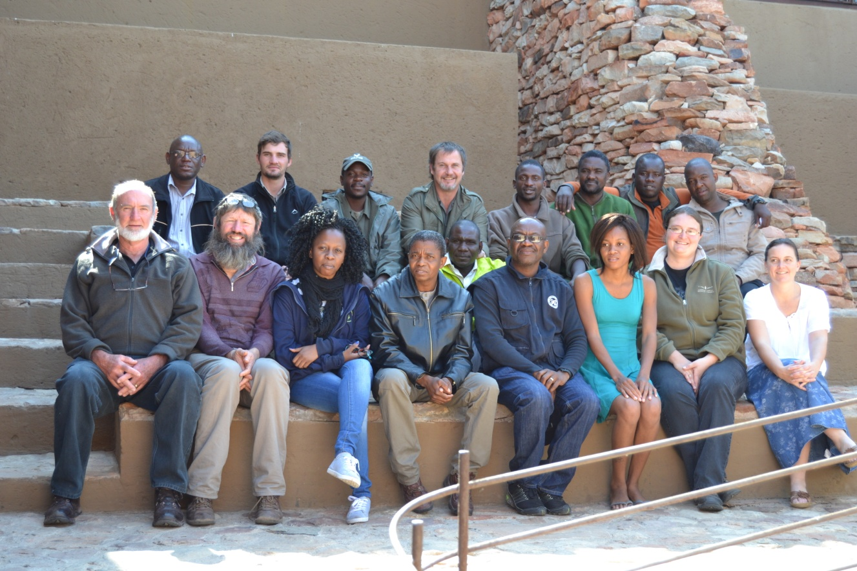
Figure 1. Group outside Mapungubwe Auditorium at Mapungubwe National Park
Table 2. Stakeholders that participated in the Greater Mapungubwe TFCA training

Title | Name & Surname | Country | Position held, Organization, Email, Contact number
MR | Stefan Cilliers | South Africa | Senior Section Ranger; Mapungubwe National Park; stefan.cilliers@sanparks.org ; 082 887 9724;
MR | Martin Engelbrecht | South Africa | Conservation Manager; Mapungubwe National Park; martin.engelbrecht@sanparks; 084 801 6340;
MR | Reckson Mashaba | South Africa | Section Ranger: Mapungubwe National Park; reckson.mashaba@sanparks.org; 082 626 5550;
MR | Innocent Lebepe | South Africa | Field Ranger Corporal; Mapungubwe National Park; mathokone@yahoo.com; 073 744 3942;
MR | Adam Bristow | Zimbabwe | Section Manager; Sentinel Ranch; adamjbristow@yahoo.com; +2760 662 4560;
MR | Peter Ncube | Zimbabwe | Campfire Officer & Local Economic Development Officer; Zimbabwe-Maramani Communal Areas; pncube@bbrdc.co.zw/peterncb4@gmail.com; +263 772 923 156;
MR | Goitsemodimo Nyamakonde | Botswana | Anti-poaching Agent; Northern Tuli GR Western Region; goitse@tuliblock.com; +26775267874/0731158227;
MR | Gaogakwe Chabalala | Botswana | Anti-poaching Agent; Northern Tuli GR Eastern Region ; +2677 489 6895;.
MR | Orebotse Rex Masupe | Botswana | Anti-poaching Agent; Central & Northern Tuli GR Region; rexbots@yahoo.com; +2677 574 9609;
MR | Moemedi Mankge | Botswana | Wildlife Warden Community Support and Outreach; Department of Wildlife and National Parks; moemedimankge@gmail.com;+2677 294 0889;
MR | Micheal Kabelo Metsimabe | Botswana | Wildlife Warden Estate Management; Department of Wildlife and National Parks; mkmestimabe@gmail.com;+26772260423;

Outcomes

Participants engaged well during the communication training and participated in an interactive way during the group exercises. Discussions were fruitful and participants mostly seemed to grasp the content being addressed. Their co‐operation and positive attitudes were encouraging.

The law enforcement course was a good first step to getting further development and interaction on a field ranger level among the parties of the GMTFCA, South Africa, Botswana and Zimbabwe. The law enforcement training had both a theoretical and a group discussion component each day. The “training block assignment” required each individual to develop a “Protected Area Security Operations Plan” in order for them to have background knowledge and experience on how to execute Security planning from a managerial aspect. The compilation of SOP’s ensures there is proper structure, command and control and final execution of operational plans. Each participant was therefore given the necessary training to be equipped with the knowledge needed to effectively conduct and plan Law Enforcement Operations within their allocated portion of the Protected Area.
Tactical and strategic planning with regards to planning Security operations and management plans within a Protected Area was to some extent already in place but the communication side of operations was discussed in depth in terms of operation protocol. There was some concern with regard to the use of social media (i.e. Whatsapp) in terms of confidentiality but guidelines were given as to what could possibly be communicated and what shouldn’t be communicated. Network in this area is poor at times and although the group felt Whatsapp is useful there was a concern important messages might go lost or breached, thus the main form of communication would remain directly phoning the opposite country for assistance.

It was also stressed that relationship with nearby communities as well as the police on the 3 sides needed to be upscaled and procedures for crossing the borders after a hot pursuit were discussed in detail. A general map of meeting points between the 3 countries was developed by them and discussed in depth (Figures 2 & 3).
a)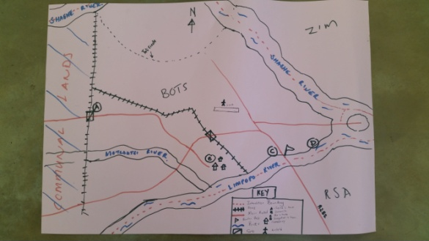
b)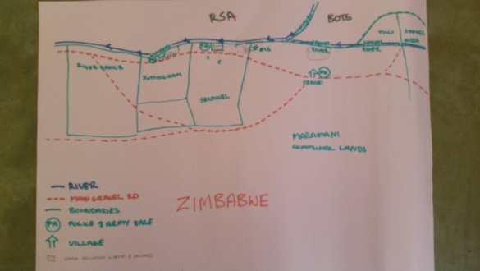
Figure 2. Maps compiled for a)Botswana side and b) Zimbabwe side of the border.

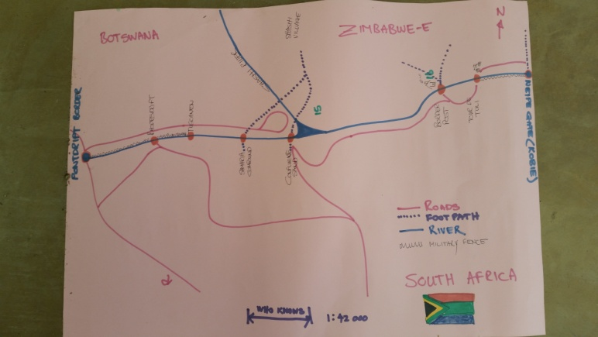
Figure 3. Road Map with meeting point compiled for the three countries.

The three main outcomes discussed to implement as of immediate effect to improve law enforcement operations and communication within the TFCA were:

- The creation of Whatsapp group named: GMTFCA. The idea is that only the relevant people have access to this group and that only official matters will be posted for the information of the group regarding their operation efforts.
- Monthly Report: The report will be by the selected representative of each country and will serve to inform the various stakeholders from each country involved in law enforcement efforts within the TFCA. The report will serve as a means of communication but also as a means of keeping track of the current situation on the relevant sides and how to improve. The format of the report could include the following for example: Title: GMTFCA, Task Team, Date: August 2014 (and to be sent out no later than 7 Sept).
- Illegal border crossings (crossing points, gps location, other information like areas of high snare density).
- Number of snares and locations (map of areas of SA, ZIM, BOTS) – Pontdrift to Weipe (hand drawn is suitable).
- Arrested people (case numbers, location of arrest, id number, picture, repeat offenders, nationality, cause, name of offender) in table format.
- Names of current managers & rangers on either side for collaboration.
- Other issues /activities (incidents, time & date in table format).
- Challenges (e.g. transport, equipment, safety)
- Upcoming events (training, meetings, venue, dates etc)
- Successes/Achievements
- Contacts of all relevant people.
- Current field rangers employed.

3. Informal River meetings: Informal meetings, monthly, between rangers in the riverbed to be communicated between each other (arranged before or on ad-hoc to discuss important matters).

Other long term goals discussed
- Proposal for cross border radio communication for TFCA Officials
- Obtaining more Cyber trackers with the possible assistance of the SAWC
- Building of a long term Cyber tracker database
- Follow up workshop on Cyber tracker and its use in communication
- Community Engagement Issues
- Field ranger training and cross border cooperation.

The first monthly report was produced in August 2014, a month after the completion, of the training. As with the monthly reporting the informal meetings have been taking place.
With reference to other long term goals, point (ii) above, one of the participants managed to secure funding, through PPF, for further cyber tracker units for use by the TFCA as a whole.

Greater Limpopo Transfrontier Conservation Area

Coordination: Ms. Marilize van der Walt
Course Evaluation: Mr. Ruben de Kock

The Greater Limpopo Transfrontier Park links the Limpopo National Park in Mozambique; Kruger National Park in South Africa; Gonarezhou National Park, Manjinji Pan Sanctuary and Malipati Safari Area in Zimbabwe, as well as two areas between Kruger and Gonarezhou, namely the Sengwe communal land in Zimbabwe and the Makuleke region in South Africa into one huge conservation area of 35 000 km².The GLTFCA brings together some of the most established wildlife areas in southern Africa.

When one considers the short duration for the intended training and the development(s) that have taken place within the GLTFCA it was felt the best way to obtain a training need for the GLTFCA was through the system that is already in place. Piet Theron (International Coordinator GLTFCA) was asked to investigate and provide a topic that would fit with plans already in place for the TFCA. The GLTFCA was keen to do training on joint anti-poaching operations. The GLTFCA is in the process of getting approval for cross border operations and it was deemed necessary for trainers to be trained on aspects such as joint operations, communication, development and implementation of SOPs, legal aspects, etc.

Participants

There were fifteen participants at the Greater Limpopo TFCA training, 8 from Mozambique, 3 from South Africa and 4 from Zimbabwe (Figure 4, Table 3).
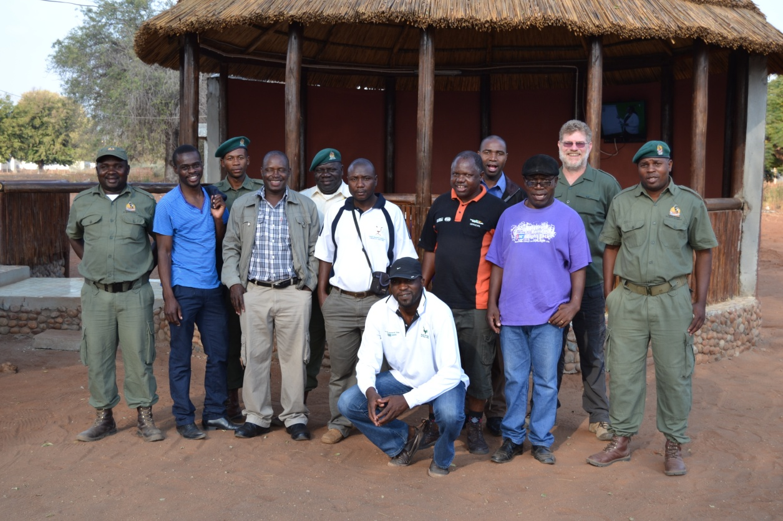
Figure 4. Participants with trainer at Massingir, Limpopo National Park

Table 3. Participants and their details for the GLTFCA training

Name | Country | Contact | Position & Organization
Mr. Marius Renke | South Africa | C.+2778 943 116, W.+2713 735 5597 | Section Ranger, Special Projects, SANParks, marius.renke@sanparks.org
Mr.Dalton  Mashangu Mabasa | South Africa | t.+27137356610 c.+27847001487 | Section Ranger, Special Projects, SANParks, dalton.mabasa@sanparks.org
Mr.Ennias  Jafter Saungweme | Zimbabwe | t.+26339266414 c.+263773602352 | Investigations Officer, NPWA
Mr.Kudakwashe Magomba | Zimbabwe | t.+263773473532 c.+263773473532 | Senior Wildlife Officer, NPWA, kmagomba@gmail.com
Mr.Daniel Sithole | Zimbabwe | t.+26324410 c.+263775971799 | Area Manager, NPWA, dsithole55@gmail.com
Mr.Chamunogwa Svosvai | Zimbabwe | t.+26339266414 c.+263772554731 | Area Manager, NPWA, csvosvai@zimparks.ac.zw / chamusvosvai@yahoo.wm
Mr.Nelson  Pecho Chivinde | Mozambique | t.+258225225/6 c.+258867438983 | Special Force, LNP
Mr.Jose  Miguel Costaguedes | Mozambique | c.+258868253294 | Law Enforcement Advisor, Protection ZVI, PPF/LNP, jmiguel.guedes.ppt@gmail.com
Mr.Jose Selimane Zavale | Mozambique | c.258862776806 c.258826018503 | Regional Ranger, LNP, joze.zavale@yahoo.com.br
Mr.Helder  Alfredo Mandlate | Mozambique | c.+258861555116/+258826323380 | Regional Ranger, LNP, helderaamandlate@gmail.com
Mr.Pintos  Armondo Chauque | Mozambique | t.+25828225225/6 c.+2588251283 | Section Ranger, LNP
Mr.Jose Filimao Sitoe | Mozambique | t.+258843011729,c.+258823790380 | Principal Ranger, LNP, josesitoe155@yahoo.com
Mr.Samuel  Jorge Chauque | Mozambique | t.+25828225225/6 c.+258828370805 | Section Ranger, LNP
Mr.Romao Caudido | Mozambique | c.+258826167953 | Coordinator, LNP
Mr.Tomas Twarisani | South Africa | t.+27157937336 | SAWC Environmental Monitor, SAWC, monitor@sawc.org.za

Outcomes

The most pressing strategies put in place by the participants was proper communication lines and a standard operating procedure for hot pursuits of poachers cross border (Figure 5). This information for the three sides was crucial as there has not been an opportunity in the past for proper collaboration strategies to be set in place. Due to sensitive planning issues and strategies there was adaptation to the training presented as a proper screening process by organizations involved did not allow for an open forum. One cannot underestimate the need for such process as it is part and parcel of the protection of our valuable and endangered species.

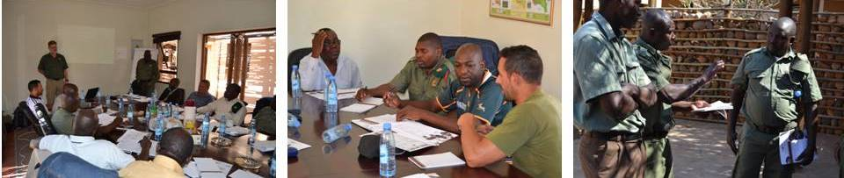
Figure 5. Many discussions occurred during the GLTP training.

2. Standard Operating Procedures for Hot Pursuit Cross borders
The three countries participants attentively discussed a definition for the terms Hot Pursuit across borders to get all on the same page. Changes to this definition might be formulated in the near future by all the parties. It was also decided that the legal impact for crossing border with arms and ammunition could not be solved by the participants and the purpose of the Standard Operating Procedures was adapted to read hand over Hot Pursuit operations.
Definition of Hot Pursuit: Discovery of recent poaching activity and/or poachers and pursuit/follow up across international boundaries within the TFCA. “Recent” in this definition is defined as poaching activities committed within the past 24 hours.

There were also other issues discussed among participants in terms of long term collaboration, these are listed below:
- Incentives for field rangers: Looking into the possibilities
- Disincentives for field rangers for disloyalty to organization
- The training of staff to understand and apply Essential Elements of Information (EEI) and Essential Elements of Friendly Information (EEFI)
- Informer payment systems and network development
- Law changes? Way forward?
- Standard Operating Procedures that fill up the gap between policies and activities. These should clarify the activity pertaining to the policy but the selection of attendees should include proper screening to ensure sensitive issues can be presented and discussed.

Lubombo Transfrontier Conservation Areas

Coordination: Ms. Marilize van der Walt
Course Evaluation: Dr. Hannah Barnes and Mr. Tiaan Kleinhans

The Lubombo TFCA is an area that spans Swaziland, Mozambique and South Africa. The TFCA consists of 5 mini-TFCAs, i.e. Ndumu-Tembe-Futi TFCA between Mozambique and South Africa (SA); Ponto do Ouro-Kosi Bay Marine and Coastal TFCA between Mozambique and SA; Nsubane-Pongola TFCA between SA and Swaziland; Lubombo Conservancy-Goba TFCA between Mozambique and Swaziland; and Songimvelo-Malolotja TFCA between SA and Swaziland (recently incorporated into Lubombo TFCA).

Human Capital Development is a key pillar for success in the Lubombo TFCA. Developing capacity at different levels in the TFCA will contribute to the impact the TFCA can make on Biodiversity Conservation within the TFCA and also the impact the TFCA can have on livelihoods. For example: vocational training, technical skills like; project management, tourism management, field ranger skills and maintaining area integrity will improve current management of conservation areas as well as provide capacity for the management of newly established conservation areas (e.g. community conservation areas and the MPMR). In addition, new jobs will be better competed for by people living within the TFCA if they are given the occupational skills to do so. Community Based Natural Resource Management and related training will improve the understanding and the ability for conservation managers and communities to better co-manage areas.

In consultation with the role-players and stakeholders of the Lubombo TFCA it was agreed that there are significant capacity building needs within civil society in the TFCA. Addressing these needs would enhance the capacity of civil society to contribute to the improved development and management of the TFCA, whilst simultaneously making a contribution to the socio-economic development of the TFCA. Much of this training would have to take place over a longer time period, not five days, with a detailed training plan. For this initial training the subject matter chosen was communication & law enforcement. The modules are provided below:

Module 1: Communication in the Transfrontier Conservation Area.
- This module focused on highlighting the means of communication available to the TFCA taking into consideration the limitation that policies and resources available to the stakeholders. Trainer: Dr. Hannah Barnes.
Module 2: Protected Areas Standard Operating Procedures.
- This module focused on what security measures are needed within protected areas, how to put these in place and implement them. Further training needs where also discussed and what options the Lubombo Conservancies have in terms of further training. Trainer: Mr. Tiaan Kleynhans, SAWC under the African Field Rangers Training Division.

Participants

The training was conducted at the Malolotja Environmental Education centre in Swaziland. The course was attended by various role players from different National parks within the TFCA, 5 from Mozambique, 3 from South Africa & 6 from Swaziland (Table 4, Figures 6 & 7).
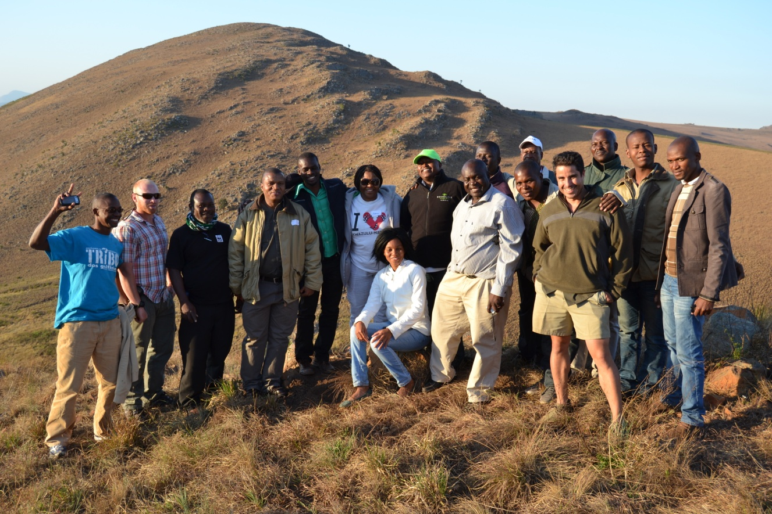
Figure 6. Participants of the Lubombo TFCA in the Malolotja National Park.

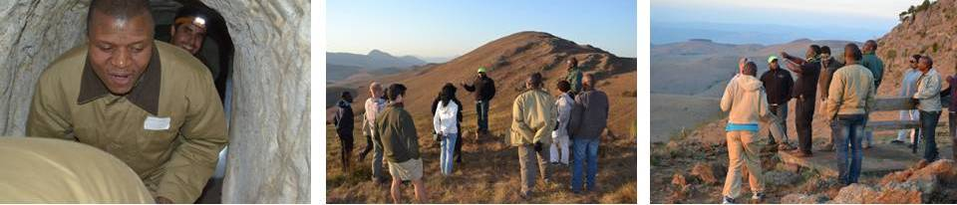
Figure 7. Field trip to an old mine and to a Malolotja Mountains viewpoint.

Table 4. Participants and their details of the Lubombo TFCA training

 | PARTICIPANTS | COUNTRY | CONTACTS | POSITIONS & ORGANIZATION
MS | Leseho Sello | South Africa | +27828712429 | International Coordinator - Lubombo TFCA, leseho.sello@up.ac.za
MR | Amos Ndlovu | South Africa | 27766945598 | Principal Field Ranger, Songimvelo
MR | Bheki Sydney Nkosi | South Africa | 27723389929 | Field Ranger, Songimvelo
MR | Tal Fineberg | Swaziland | 26876913722 | Mbuluzi Game Reserve Manager, Lubombo Conservancy/Goba. mbuluzi@swazi.net
MR | Isaiah December Dladla | Swaziland | 26876272673 | Natural Resource Coordinator/Shewula Camp Manager, decemberisaiahd@gmail.com
MR | Milton M Mamba | Swaziland | 26876036679 | Ecologist, Malolotja National Park, mduntfulini@gmail.com
MR | Elmon. V. Tembe | Swaziland | 26876115695 | Law Enforcement Warden, Lubombo Conservancy, elmonvusitembe@ymail.com
MR | Seth Maphalala | Swaziland | 26 876 037 711 | TFCA Programme Manager, Lubombo TFCA, tfca@sntc.org.sz/masethana@yahoo.com
MR | Teddy Dlamini | Swaziland | 26876485917 | Acting Senior Park Warden, Lubombo Goba TFCA, woodietp@gmail.com
MR | Sonnyboy Bandla Mtsethfwa | Swaziland | 26876443707 | Law Enforcement Warden, Mantenga NR, mtsetfwa@gmail.com
MR | Natercio Samuel Ngovene | Mozambique | 25882024828 | Head Anti-Poaching, MSR, natercio.ngovene@gmail.com
MR | Domingos Augusto Mathe | Mozambique | 258823280479 | Field Ranger, MSR, domingosmathe81.gmail.com
MR | Rodolfo Cumbane | Mozambique | 258825990970 | Ecologist, MSR, cumbanerodolfo@yahoo.com/rodolfo.cumbane@gmail.com
MR | Tiago Nhazilo | Mozambique | 258823034957 | Community Enforcement Technical Advisor, MSR, nhazilo@yahoo.com.br
MR | Fillimon Javane | Mozambique | 258827276434 | Ranger, RMPPO, MITUR, filimorejavane1@gmail.com

Outcomes

Module 1 (2 Days): Communication in the Transfrontier Conservation Area
Compared to other TFCA’s there was a more subdued group dynamic evident in this group. This could be due to a number of reasons such as there being more participants, an unusual training room layout, the individuals present or perhaps the presence of the TFCA coordinator. The participants engaged willingly throughout the communication training (Figure 8). They all participated as required and interacted amiably and interactively during the group exercises. Having participants that vary so much in terms of levels of literacy, English fluency and job levels remains a challenge.

The participants agreed on four main objectives to immediately implement within the TFCA’s:
- Creation of a properly managed Facebook Page (to be created) linked to a Lubombo TFCA website (also still to be created).
-Set up of Facebook Page: Mr Tal Fineberg
-Administrators of Facebook Page: Ms. Leseho, Mr. Seth & Mr Tal
-Due date for Facebook to run: suggested date 30 September 2014
-Name of page: Lubombo Transfrontier Conservation Area
-Provide links to existing web pages: National Parks, Private Stakeholders, Places, and Activities in the region
-To create these links Tal has requested that a form be sent out to all stakeholders who wish their activities or properties to be promoted and must include the following information:
  - Bush or Beach Experiences, Culture & heritage, Wildlife & Birding Experiences, All adventure activities available, Involvement in Projects; funders, volunteers etc, Routes and maps
-Suggestion that major partners be included on the site i.e. Peace Parks and the three countries flags as the back banner on the site.

- To have a video marketing tool to advertise the resources of the 5 TFCA’s for the rising tourism industry.
-Current video footage available within the TFCA be collected and sent to the coordinators who will then find someone to edit and compile an up to date video.
-To be uploaded onto YouTube, Facebook sites.
-PowerPoint video’s also to be created as a tool.
-To be used as marketing tool, for internal education for staff in organizations.
-Footage to be sent to Ms. Leseho Sello who will then get it to the correct people to edit where needed.
-Dr. Hannah Barnes stated she would be willing to make a short video from already existing footage that can be sent to her from the TFCA.
-SAWC to possibly inform the coordinators when foreign clients with students wish to practise their skills and in this way provide a low cost methods for attaining up to date video footage.

3. To make an information booklet or page of all the areas and its facilities with the necessary information the tourist would need which are distributed at all relevant points within the TFCA.
-Travel advice in terms of distance, coordinates to places, best routes, border information, emergency procedures, medical alerts (Malaria etc), links to weather bureau.
-Information from property owners need to compile a proper information base. Mr. Tal Fineberg was asked to compile this information sheets and circulate it to the coordinators and landowners.

- There is a need for stakeholders, from the same TFCA, to try to come together at least on a quarterly basis, and also possibly a yearly meeting where all the TFCA’s of the Lubombo conservancy can come together to discuss the way forward.
-It was recommended that due to lack of funds, Skype conference meetings should be a possible means to bridge the gap for the quarterly meetings.
-A network sheet to be compiled by the Mr. Tal Finberg and the TFCA coordinators to circulate to stakeholders for increased participation.

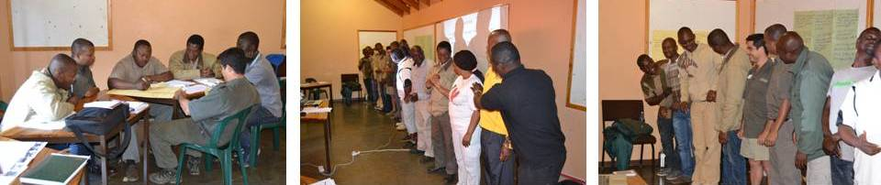
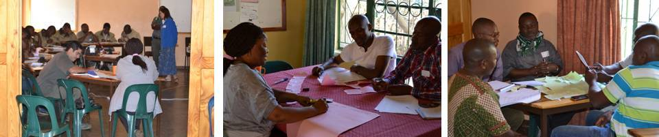
Figure 8. Participants practical sessions during the communication module.

Module 2 (3 days): Protected Area Security Operations Planning.
The PASOP training was presented in such a manner that all students had to involve themselves in discussions and group work in order for them to better grasp and understand the important details of the course. The “training block assignment” required each individual to develop a “Protected Area Security Operations Plan” in order for them to have background knowledge and experience on how to execute Security planning from a managerial aspect. All the students preformed immensely well with the assignment and it was clear to see that they all learnt many new skills.

The planning and implementation of Standard Operating Procedures were discussed in depth with the participants. Practical exercises were conducted to reinforce the understanding of a set procedures and the actions involved. Students also had to develop Operational SOP’s for their specific TFCA in order for them to have a better success rate when it comes to joint Law enforcement operations that involves cross-border co-operation. This is due to the fact that SOP’s ensure that there is proper structure, command and control and finally execution of operational plans. The students took some time to switch their mentality and attitude in order to think more tactically and strategically with regards to planning Security operations and management plans within a Protected Area. Eventually everyone acquired the appropriate and necessary skills to ensure that security in their protected areas are in capable hands.

The participants made some recommendations for their own parks and individual TFCA’s, but no formal plans could be put in place officially as all the relevant people from the various individual TFCA’s were not present. However, suggestions would be forwarded to be discussed and implemented where possible.
Areas of concern that were identified for MSR:
- Access control at gates and international borders.
- Procedures for searching a suspicious or tourist vehicle.
- Line of communication: Communication with the other side of the boundary needs to be improved although some measure is already in place.

On a local level not all communication resources are available throughout the TFCA’s. Songimvelo Nature reserve only rely on binoculars and radio communication between field rangers and their HOD’s, but have no GPS equipment for accurate communication of information. It would be beneficial to do a more in depth needs analyses within each of the TFCA’s to determine what reserves have available to them and possibly find funding to equip and train the parties on both side together in the use of the equipment.

On a national level cross border communication is also limited by the various states policies regarding national safety but is crippling effective communication between field rangers from both sides. If they do communicate it is via their managers via radio communication who then in turn call via land phone to their counterpart manager across the border who then have to pass the necessary information to their personal on the ground. This causes time lags and potential for miscommunications.

4. Maluti-Drakensberg Transfrontier Conservation Area

Coordination: Ms. Marilize van der Walt
Course Evaluation: Dr. Alan Gardiner, Dr. Hannah Barnes and Ms. Sandy du Plessis

The Maluti-Drakensberg Transfrontier Conservation and Development Project is a collaborative initiative between the Governments of the Kingdom of Lesotho and the Republic of South Africa. The main objectives of the project area is to conserve the globally significant biodiversity that occurs in the catchments of the 300km border straddling the Maluti and the Drakensberg mountains, and to stimulate integrated nature-based tourism development with maximum participation of local communities. The modules are provided below:

Module 1: Communication in the Transfrontier Conservation Area.
- This module focused on highlighting the means of communication available to the TFCA taking into consideration the limitation that policies and resources available to the stakeholders. Trainer: Dr Hannah Barnes.

Module 2: Community Based Natural Resource Management.
- This module focused on finding out the current situation regarding governance and taught the basic methods for community beneficiation and how to engage communities based for fare and responsible community beneficiation. Trainer: Ms Sandy du Plessis, CBNRM trainer for SAWC.

Participants

The training took place at the Golden Gates National Park within the TFCA, there were 6 participants from Lesotho and 8 from South Africa (Figure 9 & Table 5)
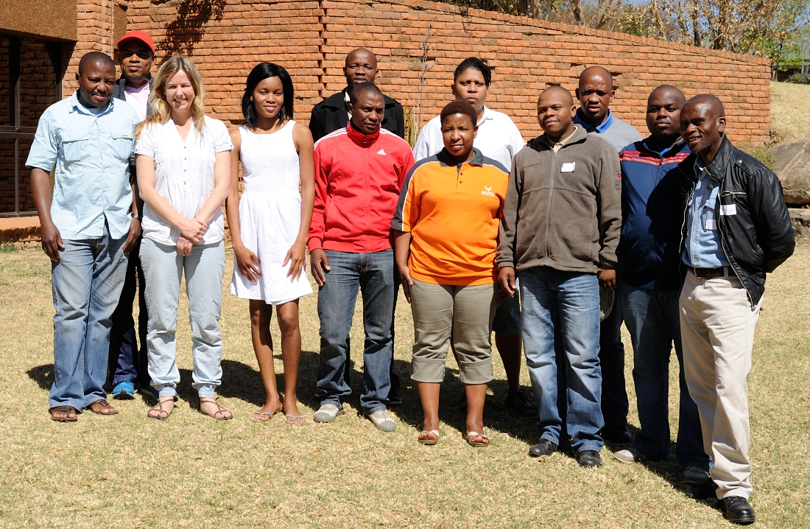
Figure 9. The participants outside the head offices of Golden Gates National Park.

Table 5. Participants and their details for the Maluti-Drakensberg TFCA training
Participants |  | Country | position & organization
Mr | Dlamini A.M | S.A | 0828486771 | Debt. Of Agriculture & Rural Development; Deputy Director: Project Management. alex.dlamini@kzndae.gov.za
Mr | Goge S | S.A | 0723305039 | Eastern Cape Parks & Tourism Agency; Reserve Manager. spho.goge@ecta.co.za
Mr | Lebamang M.C | Lesotho | +266 58997307 | Ministry of Tourism, Environment & Culture; Senior Range Ecologist. Lebamango.mabari@gmail.com
Mr | Mabongo S | S.A | 079 8971024 | Dept. of Economic, Development, Environmental Affairs and Tourism; Manager. sandiso.mabongo@deael.ecape.gov.za
Mr | Mamoa M | S.A | 072 9202 900 | SANParks; Conservation Manager. mafose.mahoa@sanparks.org
Mr | Malshi L.P | Lesotho | +266 64048844 | Ministry of Tourism; Senior Nature Conservator. kopanomalshi@rocket.mail.com
Mr | Mazibuno M. | S.A | 082 302 1067 | Ezemvelo; Community Conservation Officer. mlamuli77@gmail.com
Mr | Mdlalose T | S.A | 073 028 2319 | South African National Parks; Senior People and Conversation Officer Community Based . Thulani.mdlalose@sanparks.org
Mr | Mhlophe S | S.A | 071 680 9885 | SANParks; Park Manager. sithembile.mhlopne@sanparks.org
Mr | Monyatsi M.P | Lesotho | +266 6253 7565 | Lesotho National Parks; Park Manager. monyatsip@yahoo.com
Miss | Ngobeni S.G | S.A | 081 010 4927 | SANParks; People & Conservation Manager. gloria.ngobeni@sanparks.org
Mr | Shale T | Lesotho | 0026663213675 | Tourism, Environment and Culture; Park Ranger. tlotlisoshale@gmail.com
Mr | Tsukulu P.D | Lesotho | (+266) 58009910 / 63424375 | Ministry of Tourism, Environment and Culture; District Environment Officer. tsukulupd@gmail.com
Mr | Zwakala S.Z | Lesotho | +266 58995769 | Ministry of Tourism, Environment and Culture; District Environment Officer. samuelzwakala@yahoo.com

Outcomes

Module 1 (2 Days): Communication in the Transfrontier Conservation Area (Figure 10).
Four main objectives to implement immediately within the TFCA’s were identified:
- Creation of a properly managed Transfrontier Website (to be created, or the current website needs to be adjusted).
  - It was proposed that this needs to go to the Bilateral Conservation Committee which needs to then go to the National Conservation Committee for discussion regarding some queries in terms of the function and suggestions regarding the website.
  - Funding for the international website also to be clarified at the BCC and then the NCC.
  - On the South African side Mr. Sandiso Mabongo and Ms. Sithembile Mhlophe to take the request forward to the BCC, and on the Lesotho side Mr. Mohau Peter Monyatsi and Mr. Kapano Malshi to find out who would be the correct people to take the website forward.
  - Purpose of the website would be for sharing information with the public, marketing for funding opportunities, for buy in support, tourism promotions, networking opportunities, education and research information and promotion of projects, platform for news and updates, include a map of both sides in detail, and links to the various parks sites.
  - Questions to be taken to the BCC:
  - Why does the site exist? Why is it not fully functional? Why is there only a Lesotho link and not a South African one – How can both countries be represented equally without South Africa taking the centre stage?
- The variation of a blog has also been suggested to connect to the people that took part in this particular forum to make on the ground communication and information exchange better. Blog was to be created by Mr. Alex Mzulu Dlamini.
- It was clear that there is a need for an effective communication strategy between the countries on ground level as it appears that decision makers are not aware of what is happening on lower levels while decisions are made on much higher levels. This would need to be discussed at the BCC and NCC once working groups have sufficient information to feed into these committees for decision making regarding communication.
- It is also clear that funds on the Lesotho side are a problem in general due to the political situation. The South African side seems to get more tourist attraction as structures and finances are more available in terms of conservation and tourism efforts. This has left the Lesotho participants with feelings of powerlessness.

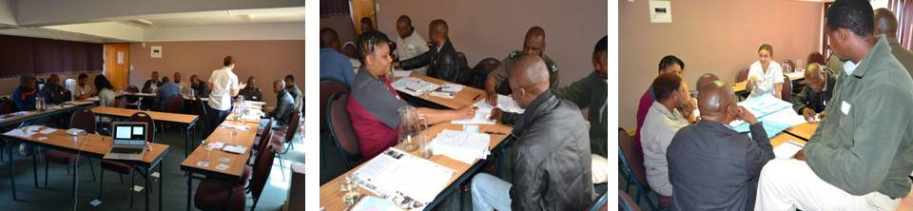
Figure 10. Participants doing the communication module with Dr. Hannah Barnes
Module 2 (3 days): Community Based Natural Resource Management.
The participants were trained in the methods of community engagement in a workshop setting (Figure 11). They were taught how to get relevant information from the community in order to compile a report which belongs to the community and would highlight what they regard as priority for their own communal land use.
From the training it was agreed that the participants would be certificated once they have completed a workshop with an actual community and forward their report to SAWC for marking to ensure that they understood the principles and the methods that were taught and practiced during the weeks training.
The following people were paired up for projects to be completed and compiled within the context of their community and the particular problems attached:
- Mr. Mohau Peter Monyatsi and Mr. Mabari Lebamang for Sehlathebe village – Lesotho,
- Ms. Sithembile Mhlophe, Mr. Thulani Mdlalose, Ms. Gloria Ngobeni, Mr. Alex Dlamini, Mr. Mafose Mamoa – Mabolela & Monontsha- villages surrounding Golden Gate National Park,
- Mr. Tlotliso Shale , Mr. Kapano Malshi, Mr. Samuel Zwakala– Kotanyane Village.

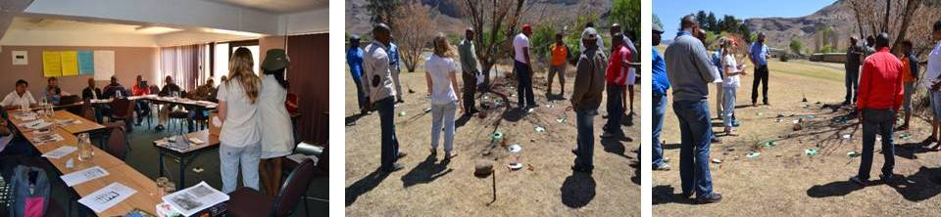
Figure 11. Participants doing the CBNRM module with Ms. Sandy Slater Jones

Chimanimani Transfrontier Conservation Area

Coordination: Dr Alan Gardiner and Ms Marilize van der Walt
Course Evaluation: Mr Absalom Kotsokoane, a CBNRM trainer associated with the SAWC and Dr Alan Gardiner.

The Chimanimani Transfrontier Conservation Area is a spectacular, panoramic landscape with rich biodiversity (including endemism) and picturesque mountainous scenery located in Manica (Land). It is made up of the Chimanimani Nature Reserve (Mozambique) and the Chimanimani National Park (Zimbabwe). It has been 15 years since the National Park and Nature Reserve have been declared a TFCA. However, both countries are at a conceptual stage and hence are operating differently and not as a unit. Social, economic and political factors play a huge role to the functioning ability of the TFCA. Nothing on the ground is taking place for this area to function as a TFCA.

Background information for Chimanimani National Park

The situation on the two sides differs. In Zimbabwe there is no Management Plan and very little is happening. In Mozambique they are acting on the Chimanimani National Reserve Management Plan. They have established their core and buffer zones and have NGOs’ helping the park to develop. The people living within the conservation area on both sides, are poor and uneducated. In Mozambique, four villages, the NGOs are working on three fronts:
- Tourism – they are helping the locals to build and run lodges. One is already operating at Nzou Camp but two others are incomplete and have run into financial problems. They are planning to develop trails and camps and home visits for tourists all managed by locals.
- The NGO, Nikai, have set up a bee keeping association and given individual families ten Kenya top bar hives and training to keep bees. They sell the honey to a private company for bottling.
- Education on conservational farming practices.

Challenges facing the park (obtained from participants)
- Almost no game (large mammals) left in the park as a result of poaching (illegal hunting).
- Huge areas of forest near the mountains are being cleared (slash and burn) for agriculture.
- Trees are being cut down to clear lands, to make fence posts, for firewood, to make bricks and for mining (deforestation).
- Late wild fires are occurring every year.
- The rivers are flowing brown, erosion from all the earth being moved for panning. Mercury poisoning due to gold panning.
- Lack of human resource, Lack of funding, lack of tourism activities, infrastructure, poor management and signage.
- Cattle are grazing in the dry season within the Corner National Park; the park is overgrazed and full of cattle paths and ticks. Exotics (pine, gum and wattle trees) are ever encroaching on the indigenous plants.
- On the Zimbabwe side there is a breakdown of law and order mainly due to the poor economy and poor governance.

The training took place just outside the Chimanimani village, Zimbabwe. The module is provided below:

Module: Community Based Natural Resource Management.
- This module focused on finding out the current situation regarding governance and taught the basic methods for community beneficiation and how to engage communities based on fare and responsible community beneficiation.
In addition some time was spent on communication, contact people and trust across the TFCA.

Participants

There were 12 participants, 4 from Mozambique (a fifth did not bring his passport and could not cross the border) and 8 from Zimbabwe (Figure 12 & Table 6).
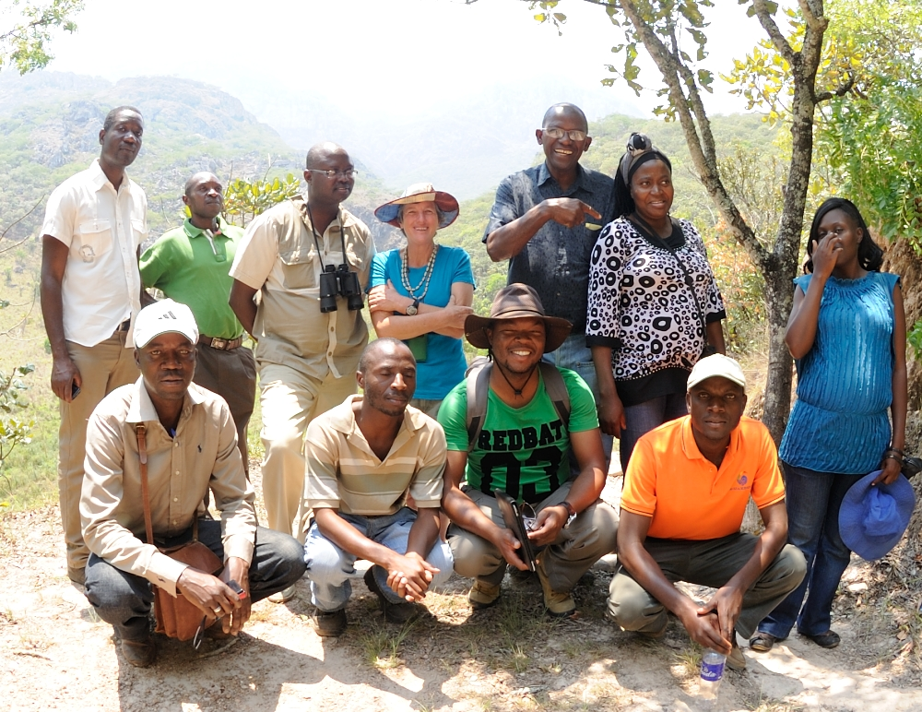
Figure 12. The Chimanimani participants with the foothills of the Chimanimani mountains in the background.

Table 6. Participants of the Chimanimani TFCA training and their details
Participants |  | Country | Position & Organization
Mr | Bande A.F.C | Mozambique | +258827640158 | Provincial Department Chief; Provincial Direction of Tourism-Manica. Angelo.bande@yahoo.com.br
Mr | Chikonda J.S | Mozambique | +258864685245 | Reserva National de Chimanimani; Officer of department of community. fsckitonda76@gmail.com
 | Chipanga H.B.C | Mozambique | +258875102262 | Micaia Foundation; Project Manager for Darwin Funded Project. Hercilia.chipanga@yahoo.com.br
Mr | Maduna P.T | Mozambique | +258863311965 | Comite de Gestar dos recussos naturais de isetserra; Presidente do comite
Mr | Gelemu S | Zimbabwe | +26304797493 +236772666796 | Zimbabwe Parks and Wildlife management Authority;  Tourist Officer. stanleygelemu@gmail.com
Mr | Chinyanuanya G | Zimbabwe | +263773023469 +2632272579 +2632273367 | Zimbabwe republic Police; Superintendant
Mrs | Mangungo K.M | Zimbabwe | +2630263352 +263772953586 | Parks and Wildlife Management authorities; Area Manager. ikanengoni@yahoo.co.uk
Mr | Marange E.N | Zimbabwe | +263739939729 +2630262461 +2630773509854 | Environmental Management Agency; District Environment Officer. emarange@webmail.co.za
Miss | Mufandaidza T | Zimbabwe | +2630268352 +2630775185526 | Forestry Commission;  District Forestry Extension Officer. tmufandaidea@gmail.com
Mr | Mugani T | Zimbabwe | +263262547 +263773503711 | AGRITEX (Ministry of Agriculture); District Agriculture and extension officer. tmugany@gmail.com
Mr | Mwafuka T | Zimbabwe | 0262272/3 2914/5 0773753681 0262403 | Chimanimani Rural District Council; Environment Officer. tmwafuka@gmail.com
Mrs | Van de Ruit T.J | Zimbabwe | +2630263351 +2630772101283 | Chimanimani Tourist Association; Director. dougvan@zol.co.zw

Outcomes

Daily activities were flexible due to both the level of infrastructure of the venue and language differences. In addition time was spent discussing issues arising from the participants.

The participants were asked to indicate what their expectations of the workshop were. This information provided a strong foundation for understanding the priority areas for discussion within the workshop.
Summary of the expectations:
- How can we link stakeholders in conservation?
- How can we link conservation and livelihood? (Stakeholders, NGO, Government, Private Sector etc.)
- What approaches can be used to improve ownership to communities for better resource management?
- How do we engage with government for support and participation on community projects?
- How can communities benefit from the park?
- How do we deal with challenges caused by communities?
- What tools can be used to enhance community participation?
- How can we effectively communicate conservation issues to communities suffering from human wildlife conflict?
- How can we involve kids to participate in conservation?
- How does the community work with the private sector, and how do we move on once a joint venture has lapsed?
- How do we involve communities to ensure safety and security?
- How do we as NGO/Government work with community rangers who are not paid (volunteers)?
- In Mozambique how can we effectively use the 20% entrance fee that is given by Government to communities per year?

The participants were extremely interested in understanding the significance of the park towards improving their lives and livelihoods. This was revealed through their concern about matters of access to the park, benefits from the park, as well as a strong desire to understand how the park is managed. They were also largely interested about how do they get the community involved in bringing and restoring the park back to its original form.

People and Parks Map
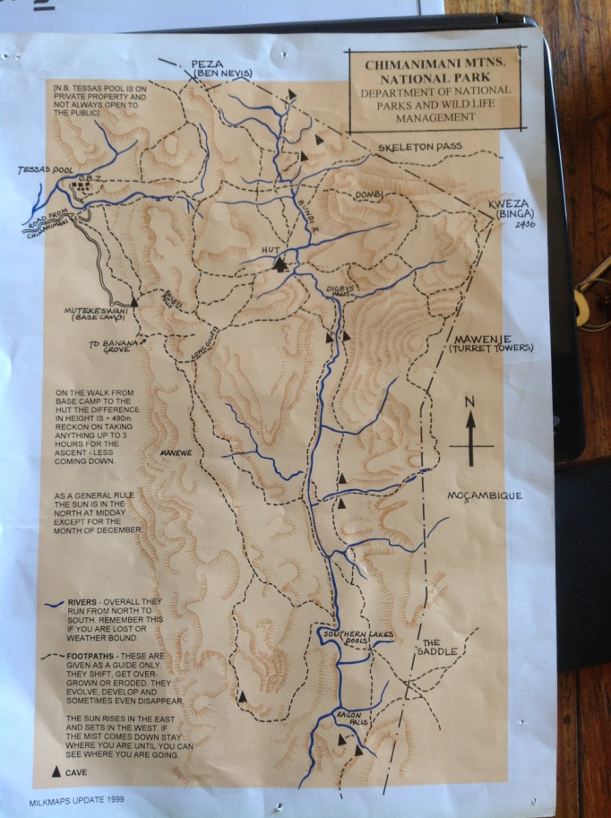
The participants were divided into two groups, mixed per area and work position. The task was to identify unhealthy and healthy land use practices, with the aid of maps (Figure 13), and to recommend stakeholders who they feel can help rectify the situation. It was interesting that both groups, named the surrounding communities as the stakeholder for solution in their respective areas. Unfortunately many of the Zimbabweans showed signs of unwillingness to start rectifying the challenges faced.

Figure 13. Map of the Chimanimani National Park one of the maps used to help people identify different land use practices.

Presentation on Chimanimani Management Plan
Julio Chikonda presented the Management plan for the Mozambique side of Chimanimani. The conservation area is large, stretching from Tsetsera in the North to the Rusitu in the south. Mozambique has more forest remaining than Zimbabwe. Mozambique also has a problem of lack of manpower and finances to police the area. Gold panning in their core zone (the mountains) is rampant.

Communication & trust
The “win as much as you can” game was used to great effect and illustrated the lack of trust between the players. The participants saw how this lack of trust, especially within the Zimbabwe side, is a hindrance to the development of the area.

Field Trip
A field trip to the Outward Bound School at the base of the Chimanimani massif was organized (Figure 14) and we met Dave Miekle, the director. There were some excellent bushman paintings which were also discussed in regard to tourism possibilities (Figure 14). The group saw evidence of some gold panning which has been going on in a stream bed near the school. The way forward with respect to the gold panning was discussed.

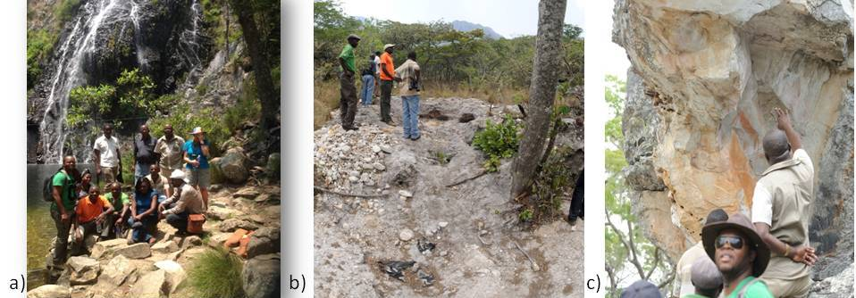

Figure 14. a) The participants at Tessa’s pool, Outward Bound School, b) examining diggings from illegal gold panners and c) examining rock paintings at the base of Chimanimani Mt.

The participants were given an action plan:
- to give feed back to their respective counterparts in their organizations,
- Zimbabwe participants - to write a report and send it to The Provincial Director of National Parks who will be asked to get it to the CEO of National Parks. (Area Manager),
- promote exchange learning between Zimbabwe, Mozambique, South Africa and Namibia (should also include the senior official’s),
- Zimbabwe; invite the ZimParks CEO to Chimanimani to see the status on the ground and persuade a change in policy in order to try and provide an income to the community and some responsibility for the well being of the park,
- Mozambique, Hercilia will report back to colleges and implement some of the learning from the workshop,
- The participants were asked to develop a resource map for their immediate area, which should include at least 80 community members. Each country will give feedback and provide the information for their area. It will take a couple of months but the plan should be sent to SAWC to form part of their portfolio. From the training it was agreed that the participants would be provided with a certificate once they have completed this and forwarded their report to SAWC for marking. This will ensure they understood the principles and the methods that were taught and practiced during the weeks training.

Zimbabwe:
It will take time (years) to re-engage CBNRM in this part of Zimbabwe (due to political interference). However, that does not stop the Chimanimani community from using CBNRM principles to benefit for their own livelihood. The workshop was a serious food for thought to the participants and challenged them to start acting and doing their bit to improve the situation.

Mozambique:
They have an active NGO that is pushing community development issues. The relationship with the park shows growth and commitment. It will be worthwhile to investigate projects already in place on the Mozambique side and the impact it is having on the ground.

It is of importance that more collaboration takes place as the two countries are similar in many ways and the communities from both sides are often from the same families. It is the individual commitment that will pave way to a better conservation area and management.

Nyika Transfrontier Conservation Area

Coordination: Dr. Alan Gardiner and Ms. Marilize van der Walt
Course Evaluation: Mr. Rodgers Lubilo & Dr. Alan Gardiner

The Malawi-Zambia TFCA (Nyika) is situated on the North West border of Malawi and the east central border of Zambia. It covers a high undulating montane grassland plateau, with valley mountain forest. It rises over 2000m above the Miombo, bushveld and wetlands (Vwasa Marsh). This TFCA has both floral and faunal endemnism and hence is of biological importance, it is also an important water catchment area.

The infrastructure of the area is deteriorating and the condition of the roads makes access for visitors difficult. In this TFCA there is fair communication between the two countries. Even though the cross border communication is quite good they would also like further training in this regard. There is a long history of cross border movement, and communication, and for the locals the border has always been quite permeable “free” cross border movement. There is some community involvement, particularly on the Malawi side, but this aspect needs to be enhanced. The main issues are centered around governance, community involvement and cross border law enforcement.

Training

The training took place from 3-7 November 2014, at Matunka Safari Lodge on the outskirts of Rumphi town. This area neighbours Nyika National Park on the Malawi side. The training did not take place in Nyika due to the lack of facilities as the park hostels were being used by Peace Parks Foundation. Matunka Safari Lodge, a community lodge, was the only training venue the participants of all the trainings were not pleased with. The module is provided below:

Module: Community Based Natural Resource Management (CBNRM) with emphasis on Particapatory Rural Appraisals
- To equip the participants with Participatory Rural Appraisal tools and CBNRM skills; The module also found out the current situation regarding governance and taught the basic methods for community beneficiation and how to engage communities based on fare and responsible community beneficiation,
- To share experiences between the two sides of the TFCA and how to improve effective communication.

Participants

The total numbers of participants were 16, this included 8 from Zambia and 8 from Malawi (Figure 15 & Table 7).

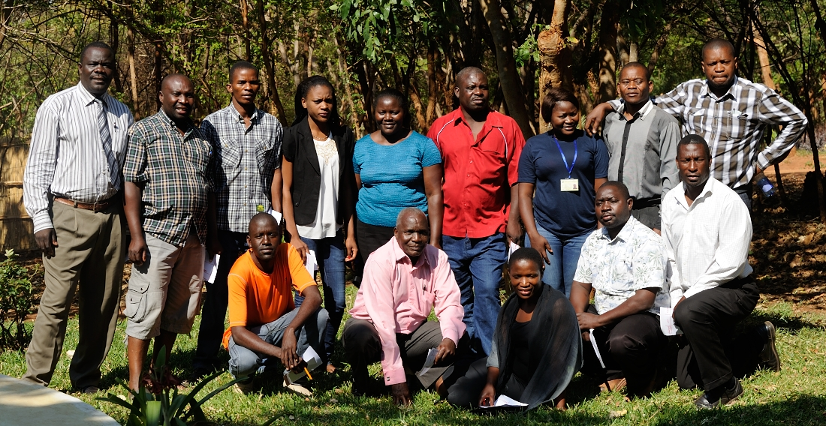
Figure 15. Zambian and Malawian participants at Rumphi, Matunkha Safari Lodge with Mr. Rodgers Lubilo standing far right.

Table 7. Participants of the Nyika TFCA training

Title | Name | Country | Contact | Position + Organization
Mr. | Bwalya Joseph | Zambia | +2609782627 | Park Ranger, Zambia Wildlife Authority, josephbwalya10@gmail.com
Mr. | Chihana Kennedy | Malawi | +265884002743 | Assistant Parks and Wildlife Officer, Department of National Parks and Wildlife, kennedychihana@gmail.com
Ms. | Chulu Maisa | Malawi | +265999205910 | Extension & Education Officer, Department of National Parks & Wildlife, maisachulu@gmail.com
Mr. | Kabonso Japhet | Zambia | +260977253140 | District Forestry Officer, jkabonso@gmail.com
Mr. | Kadauma Henry | Malawi | +265884550321 /  +265999369252 | Park Ranger, Zambia Wildlife Authority, hkadauma@yahoo.co.uk
Mr. | Kanyunka Oscar | Zambia | 0972-283000 | Route Supervisor, Olam Cotton Ginneries Zilid
Ms. | Kumwenda Charity | Malawi | 0999205685 /  0884236324 | Education & Extension Officer, National Parks & Wildlife, chkumwenda@yahoo.co.uk
Mr. | Mkandanwire Duncan | Malawi | 0884122336 | Chairman, Nyika Vwaza Association (NVA), chizaduncan@gmail.com
Ms. | Nambela Jessy | Zambia | 0976534194 | Immigration Assistant, Ministry of Home Affairs, kundanajessy@gmail.com
Mr. | Nyirenda Reggie | Zambia | 095514152 | Farmer
Ms. | Pondre Sandra | Zambia | +260966114973 | Wildlife Ecologist, Zambia wildlife Authority, pondresandra8@gmail.com
Mr. | Saukani Banda | Zambia | +260972924423 | Senior Wildlife Police Officer, Zambia Wildlife Authority (ZAWA), saukanibanda@gmail.com
Mr. | Sengeleti Winard | Zambia | +265881050113 | Park Ranger, Zambia Wildlife Authority (ZAWA), winard.ms@gmail.com
Mr. | Wadi Peter | Malawi | +265999383055 / 265881911579 | Park Manager, Department of National Park and Wildlife, peter.wadi@gmail.com

Outcomes

Introduction to CBNRM training
This began with the CBNRM video developed by USAID and WCS showing various CBNRM projects in Zambia, South America and some parts of Asia. This video explains various types of CBNRM projects, how local communities, states, and NGOs have been working together to develop CBNRM initiatives in: fisheries, bee-keeping, and sustainable wildlife utilisation including conservation agriculture. The participants where then placed in 4 groups to discuss the video by explaining key issues emanating from the video (benefit sharing modalities). This process re-enforced the participants understanding of CBNRM.
The participants in their groups discussed their understanding of the history of CBNRM in Southern Africa. The group discussions were presented in plenary. This was followed by a lecture on the genesis of CBNRM.

Understanding principles of CBNRM
A PowerPoint presentation lecture by the trainer was made to generate an understanding of the principles of CBNRM. This was followed by group discussions and presentations.

CBNRM and Property Rights
The property rights and different forms of rights were presented and discussed. Participants were then put in groups to discuss the various forms of property rights, and how they affect CBNRM programs with particular reference to programs in their area.

Case studies of CBNRM in the Region
To further assist participants to understand CBNRM in detail, a lecture and videos on the various CBNRM examples in the region were given. These included the CAMPFIRE program in Zimbabwe, the communal conservancies in Namibia showing how one of the best considered CBNRM program is operating, ADMADE and LIRDP projects in Zambia, the Makuleke in South Africa and the CBNRM program in Sabie/Mangalana community in Mozambique. This was followed by group discussions on various key issues of how conservancies are organized, the role of the private sector, donors, local NGOs and the state. Joint venture operation activities and benefit distribution were also discussed.

Introduction to Participatory Rural Appraisal tools
The participatory tools are important at the beginning of projects and during the implementation process. The following tools were discussed and the participants worked in groups to practice and improve their understanding.

Resource/livelihood map
The participants worked in groups to draw resource maps for their communities and conservation areas where they work (Figure 16). The Zambia team worked together to look at the resource map of the conservation area in Chief Kambombo area of Chama District. The Malawian team worked together on drawing the resource map of one zone within the Nyika/Vwaza area.
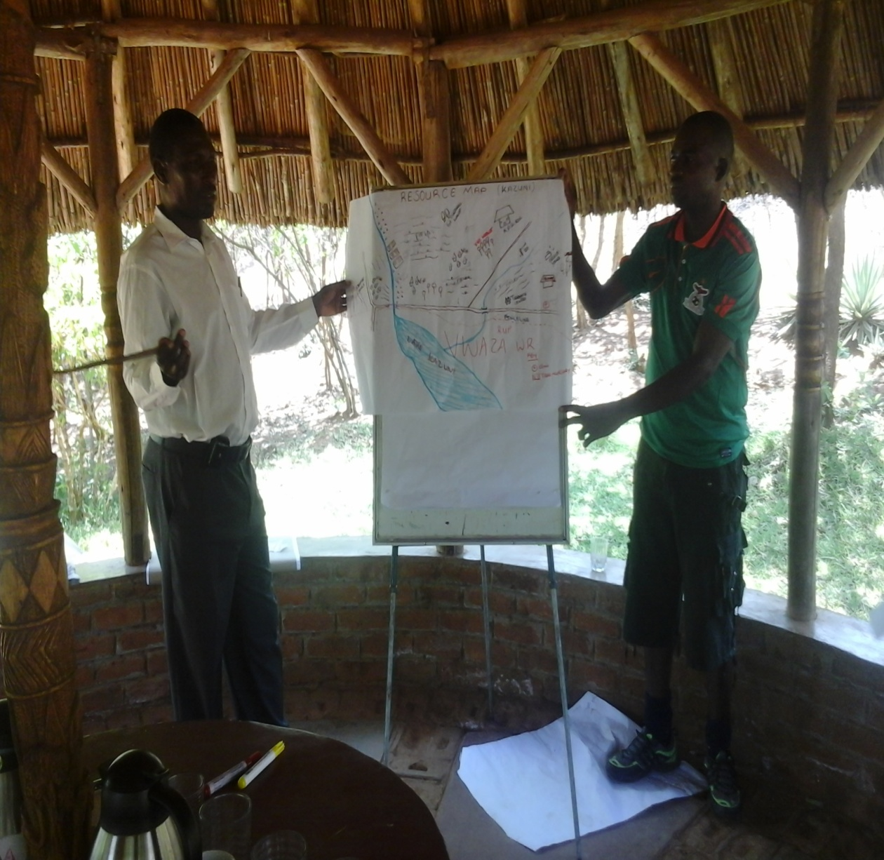
Figure 16. Participants explaining their resource map to the others.

Social Map
The two teams also worked together to draw the social maps of the various areas in Zambia (Figure 17) and Malawi. The process and understanding, including use of the social maps was discussed in groups and plenary.
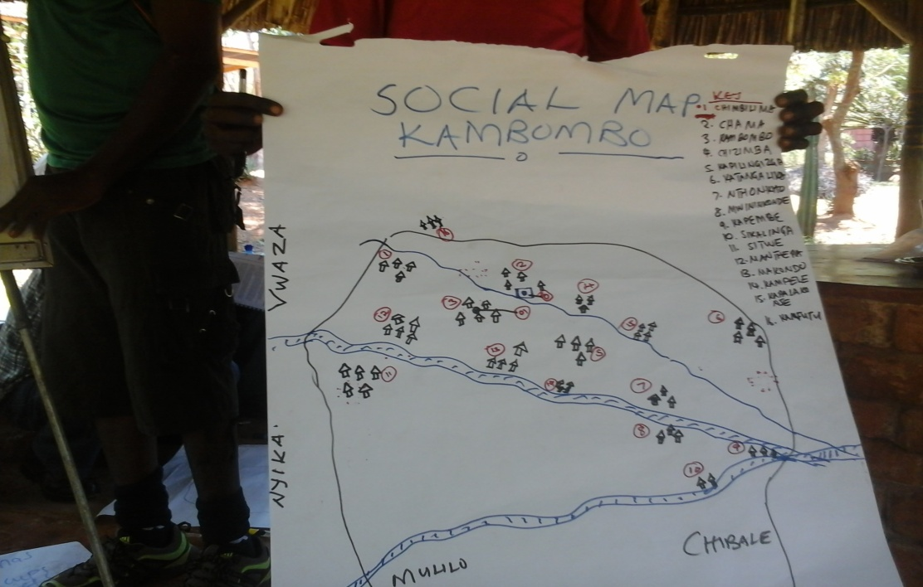
Figure 17. A social map drawn by the Zambian participants.

Future/vision map
The Malawi and Zambia teams further worked in groups to describe the future/vision map for their communities (Figure 18). This process was participatory and helped the participants to understand how they could participatory develop a vision map.
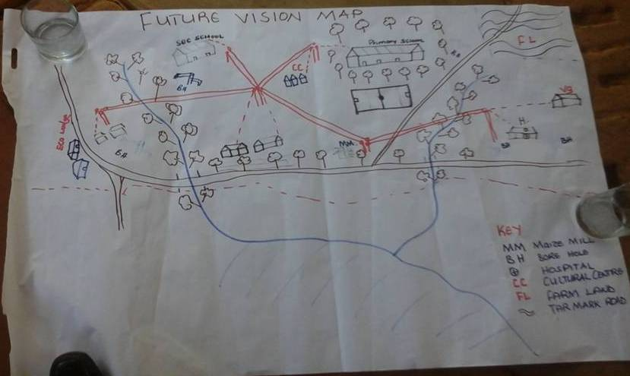
Figure 18. A vision map drawn by the Zambian participants.

Seasonal calendars and Timelines
The teams were exposed to the use and understanding of seasonal calendars and timelines as useful tools to understand what activities are conducted during different times of the year and what major events the community could remember and how it contributed and or affected the communities. The participants enjoyed practicing these tools.

Stakeholder Analysis and Venn diagram
The participants were also divided into smaller groups to work with the two participatory tools, the stakeholder Analysis and the Venn diagram (Figure 19). These can be used to identify various institutions, organisations, and their relevance/importance to the local communities and their contribution to sustainable resource utilization.

CBNRM challenges in Nyika TFCA

The trainer grouped the participants in two groups to discuss their perceived challenges, in regard to working with local communities adjacent to the national parks. This session paved the way for investigating how the parks and the people around could improve their work relationship through real partnership and sharing of benefits. The participants felt they require well defined institutional arrangements.

Effective Communication & trust
During the fourth day, the participants were taken through a lecture and practical session by Alan on how to improve effective communication in community conservation and Transfrontier areas. He paired participants into groups of 4 and did practical exercises using ‘communication games’. This helped the participants understand communication as an effective tool in conservation management.

Governance and Institutions (Dashboard)
The trainer gave a lecture on mechanisms for measuring and monitoring the performance of the CBNRM programs. An introduction of the ‘community governance dashboard was presented and discussed in detail. The participants were willing to try the tool to measure and monitor how the Nyika/Vwaza Association is managing the communities through the natural resources committees around the TFCA.
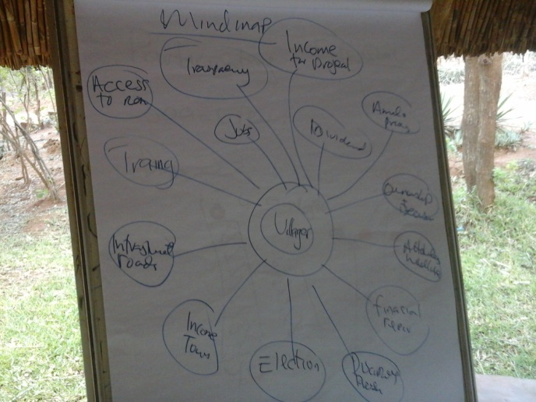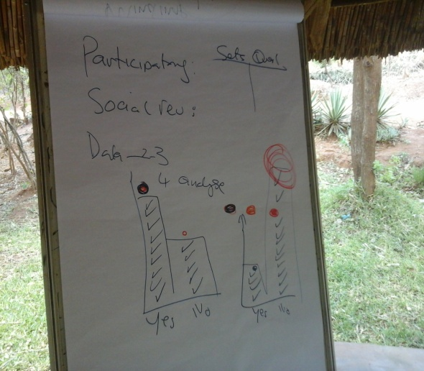
Figure 19. Lesson on Governance and institutions with diagrams illustrating the input from participants.

Group assignment
Time was spent with the participants from the two countries to discuss the post training activities. The participants could then go back to their workplaces to test the tools learned during the course.

Malawi
This side of the TFCA has more information on the park and natural resource use (Figure 20). This is due to the activities undertaken by the extension team of the department of Parks and Wildlife Services and their collection of data from the communities. They will try and identify gaps on what information is still missing. It was however found that there are still problems with the dissemination of the information back to the communities. To this end the Malawian side will investigate channels and procedures for getting information back to the communities (through the various NRCs and their sub-zones) and produce a report on their progress (Figure 20).
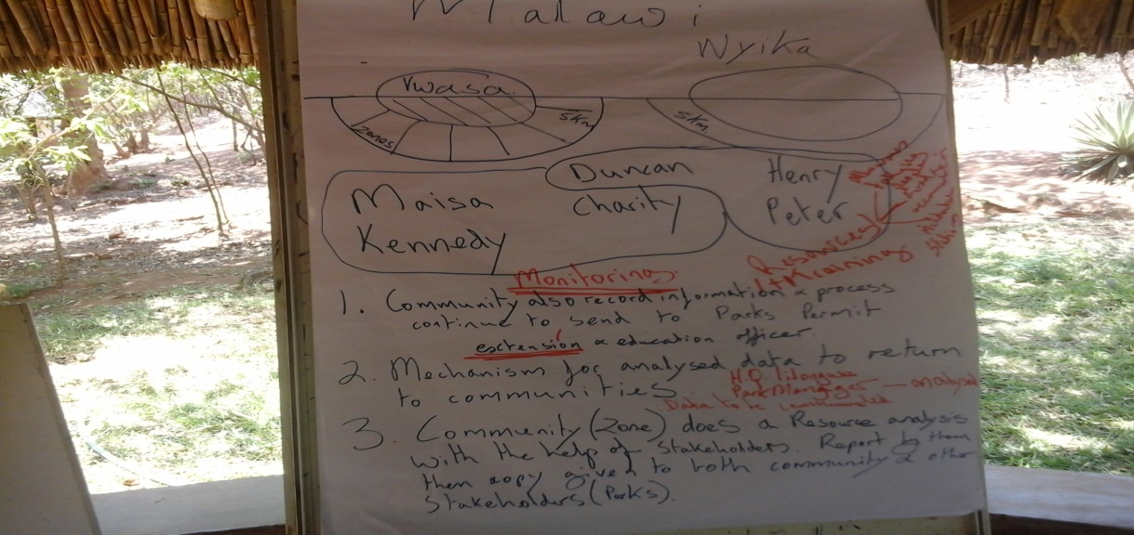
Figure 20. Identifying important aspects of community work to be taken further by the Malawi participants.

Zambia
For the Zambian team, through the discussion and situational analysis, identified the need to do thorough PRA activities. Zambia needs to put in place a system for collecting and analyzing data (Figure 21). The main output of the assignment for the Zambian team would be to produce the ‘community profile report’ of the conservation area in Chama where the World Bank is committed to provide financial support for sustainable community conservation program as part of the TFCA support.
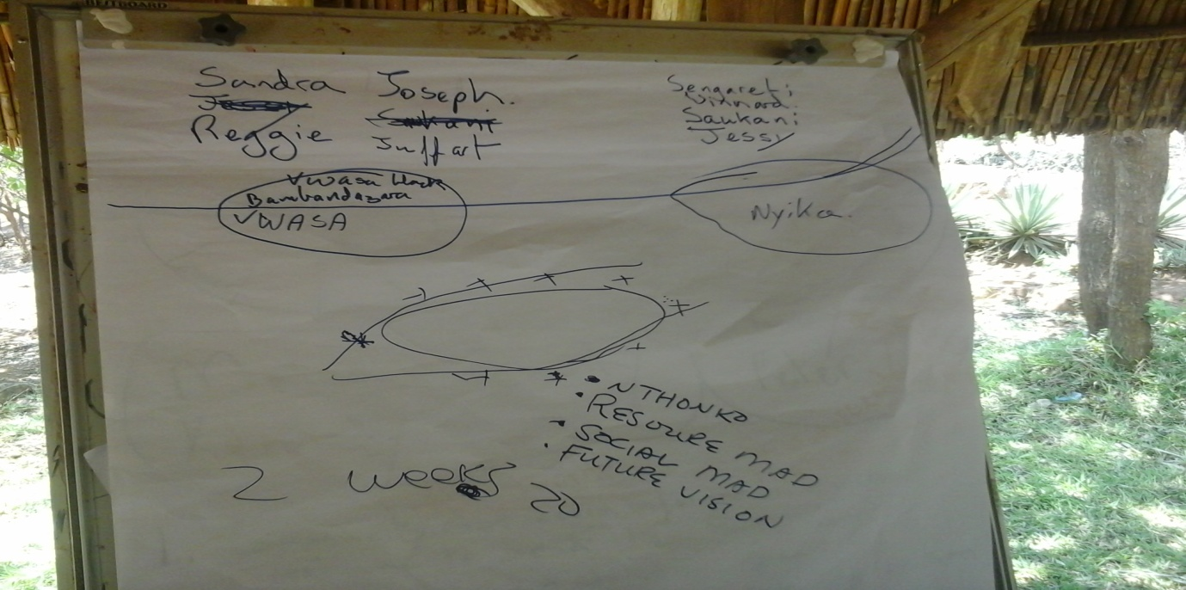

Figure 21. Diagram used to decide who will do what on the Zambian side of the TFCA.

Trainee Feedback
At the end of each course (training) the participants provided feedback by means of an individual standard SAWC feedback form. A summary of part of this information, for each TFCA and course (training subject), is provided in Table 8.

Table 8. Course feedback summary for eleven training criteria; GMC = Greater Mapungubwe communication course, GML = Greater Mapungubwe law enforcement course, GL = Greater Limpopo law enforcement, LC = Lubombo communication, LL = Lubombo Law enforcement, MDC = Maluti-Drakensberg communication, MDB Maluti-Drakensberg Community Based Natural Resource Management (CBNRM) course, C = Chimanimani CBNRM course and N = Nyika CBNRM course.

 | % of class indicating a high agreement with the question
Questions | GMC | GML | GL | L C | L L | MD C | MD B | C | N | Av
The objective of the training was clearly defined | 91 | 92 | 95 | 98 | 100 | 93 | 95 | 93 | 96 | 95
Participation and interaction were encouraged | 93 | 92 | 97 | 100 | 98 | 98 | 96 | 95 | 77 | 94
Topics covered were relevant to me | 89 | 92 | 99 | 97 | 98 | 89 | 96 | 91 | 93 | 94
The content was organized and easy to follow | 93 | 93 | 96 | 97 | 95 | 91 | 95 | 87 | 94 | 93
The material distributed were helpful | 82 | 87 | 95 | 98 | 95 | 95 | 96 | 85 | 89 | 91
The training experience will be useful in my work | 89 | 92 | 95 | 97 | 97 | 98 | 100 | 89 | 97 | 95
The trainer was knowledgeable about the topics | 100 | 100 | 99 | 98 | 100 | 91 | 96 | 95 | 100 | 98
The trainer was well prepared | 100 | 83 | 96 | 98 | 100 | 100 | 96 | 38 | 96 | 90
The trainers objectives were met | 91 | 78 | 92 | 98 | 98 | 85 | 91 | 84 | 87 | 89
The time allocated for the training was sufficient | 100 | 90 | 84 | 92 | 95 | 69 | 71 | 71 | 83 | 84
The meeting room and facilities were adequate and comfortable | 93 | 95 | 81 | 88 | 85 | 95 | 93 | 73 | 26 | 81

The results indicate the training was well defined and relevant with good trainee participation. The trainee’s also felt the trainers were knowledgeable about their course topic. Apart from Chimanimani they also felt the trainers were well prepared. Two of the TFCA’s Maluti Drakensberg and Chimanimani although happy with the amount of time the score and suggestions indicate they would have liked more time for the training. The only venue the trainees were not happy with was at Nyika, this is of interest as it is a community owned resort and indicates two things i) trainees like to be housed in good conditions even though conditions at their work place may be of a lower standard than the venue and ii) work on community projects surrounding protected areas is required in order to get them to a sufficient standard for visitors.

The feedback also highlights how important communication is to people in the TFCA’s. Many of them saw the training as the first time they could network within the TFCA and the importance of contact amongst the members of the TFCA. They also highlight the need for further training in all the aspects covered, communication, law enforcement and CBNRM. The trainees’ were very happy with the courses and the vast majority did not want it changed in any way and suggested they would incorporate their learnt material into the functioning of the TFCA.

Advantages, disadvantages and the future of Cross Border Mobile Training

The SAWC has traditionally done short term training both at the College and in situ at the protected area were training is required. However the two flagship courses, Higher and Advanced certificates in Protected Area Management, of one year length, have 8 months at the College and 4 months doing assignments in their protected area. In this project the College took the mobile training units and applied them to a TFCA situation. The advantages and disadvantages of TFCA cross border training in situ are given below.

Advantages
- The training takes place on site.
- The training focuses on real and relevant issues.
- Tends to target the correct people.
- Trainee’s feel more connected to training.
- Normally provides more relevant suggestions and interactions on how to continue after the training. This is also more “easily” discussed with the trainer as the trainer can see the situation on the ground or the trainee’s working conditions.
- Less time for trainees’ to be away from work place.

Disadvantages
- Requires time to set up logistics.
- Budgeting difficult due to the uncertainties of costs in the different TFCA’s.
- Training institute has little control on accommodation and workshop facilities.
- Requires trainers to travel and spend more time away.
- Requires a different set of training, accommodation and catering equipment (when TFCA does not have one or either).

This type of training if organized and planned correctly, and with the correct learning approach, has great potential in improving training and deliverables in the TFCA’s. The trainers should be familiar with the TFCA’s and their associated needs. Long term follow up on training and further training is required to provide a more integrated and functional TFCA. The training should not be seen as a stand-alone item. The TFCA’s need to be seen by the senior staff and organizing institutes as one unit and focus on removing the problems of a top down approach and allow process’s and staff to function at the lower level.

Conclusion & Recommendations

The success of the TFCA training is illustrated by the on ground outcomes produced. Mapungubwe, where the first training took place, has already implemented a number of aspects from the training. It is hoped that similar outcomes will be produced by the other TFCA’s, their results will take a bit longer to filter back to the College. We have had some feedback from Chimanimani but as indicated in this report, and that from the participants, much effort is required on the Zimbabwe side as the political situation there has produced additional challenges. All the TFCA’s require follow-up training with a long term plan, as also indicated by the student feedback from Maluti-Drakensberg & Chimanimani. When projects have small budgets concentrating on a few selected TFCA’s will produce more solid on the ground changes. For a number of the TFCA’s more in-depth studies on training needs for already identified subjects are required and then, in certain cases, there is the possibility of linking this training to the procurement of equipment which can be used in the training.
For this project and for many of the TFCA’s it was the first time that the participants had met their corresponding peers. This project illustrated how training needs to be delivered at the different TFCA levels. We mention this, not to blame any organization, but to highlight points that require action or improvement for better TFCA functioning. At a higher TFCA organizational level, training and protocols need to be put in place which allow a more rapid response by authorities and easier movement of stakeholders within the TFCA. This training illustrates the commitment of the people on the ground and how the training has acted as a catalyst for on the ground collaboration among the countries.

The commitment of GIZ to producing on the ground positive changes was evident throughout the project and it is hoped the College can continue to act as one of their partners in this endeavor. The on the ground changes in the TFCA’s is evidence of the success of this project. It is hoped that a similar type of training methodology can be adopted for further projects.

Acknowledgements

We would like to thank GIZ for this funding opportunity to increase collaboration among TFCA countries. Special thanks to Mareile Nganunu-Kroening for her guidance, support, patience and involvement.

We would also like to thank all the trainers that were involved Dr. Hannah Barnes for her development and training of the Communication in the TFCA module; Mr. Ruben de Kock and Mr. Tiaan Kleynhans for sharing their practical knowledge about Protected Area Standard Operation Procedure; Mrs Sandy du Plessis, Mr Absalom Kotsokoane and Mr. Rodgers Lubilo for sharing principles and knowledge on the subject of CBNRM. On the logistical side thanks to Mrs. Marilize van der Walt for her coordinator and project management skills, Dineo Chloane for logistics and the SAWC Environmental Monitors Ms Votumi Mnisi and Mr Tomas Twarisani who contributed in any way possible. Also thanks to the SAWC financial department for their guidance during the progress of the project and reporting on the project financials.

The training was made possible through the coordinators and members of staff of the various TFCA’s: Greater Mapungubwe TFCA: Patience Gandiwa International Coordinator, Fhatuwani Mugwabana South African National Parks Park Manager, Peter Ncube Campfire Officer & Local Economic Development Officer Zimbabwe-Maramani Communal Areas: Greater Limpopo TFCA: Piet Theron International Coordinator, Antony Alexander Project Manager Parque Nacional do Limpopo, Billy Swanepoel Protection and Wildlife Technical Advisor Parque Nacional do Limpopo: Lubombo TFCA’s: Ms. Leseho Sello International Coordinator Lubombo Transfrontier Conservation Area (University of Pretoria), Seth Maphalala Lubombo TFCA Programme Manager Swaziland National Trust Commission, Rod de Vletter Eco Lubombo Program: Maluti Drakensberg TFCA: Rabson Dhlodhlo Maloti Drakensberg Transfrontier Programme Coordinator Ezemvelo KZN Wildlife, Ms Sithembile Mhlophe Park Manager Golden Gate Highlands National Park: Chimanimani TFCA: Mrs Mangungo Area Manager Parks & Wildlife Management Authorities Zimbabwe: Nyika TFCA: Dominic Kapokola Area Warden Chama Zambia, Peter Wadi Park Manager Departement of National Parks and Wildlife Malawi. Finally, and importantly, we would like to thank all the participants for their effort and dedication during the training.

