Game Translocation to Matatiele Nature Reserve

Matatiele Nature Reserve (MNR) is situated on the foothills of the southern Drakensberg, in an area formerly known as East Griqualand and is located northern Eastern Cape Province of the Republic of South Africa. The reserve lies adjacent to the town of Matatiele. The Matatiele Local Municipality has had a long association with various provincial conservation organisations. The importance of the mountain grasslands, wetlands and rare species of fauna and flora has been recognised by the municipality since the 1950’s. This awareness led to the establishment of a nature reserve on the northern section of municipal commonage. There were various efforts since then to establish a larger protected area which never came to fruition. The establishment of the proposed larger protected area gained momentum in 2003 when the Maloti Drakensberg Transfrontier Project (MDTP) identified it as an important area to expand the protected area network in the Maloti Drakensberg Transfrontier Conservation and Development Area and as a pilot MDTP project for KwaZulu-Natal Province. This would contribute to the MDTP 20-year strategic outcomes for the Maloti Drakensberg Transfrontier Conservation and Development Area through more effective natural and cultural heritage conservation and mountain catchment management.

During the re-demarcation of certain provincial boundaries in 2006, Matatiele was transferred to the Eastern Cape Province. The Eastern Cape Department of Economic Development and Environment Affairs (DEDEA) then took over the pilot project together with the Matatiele Municipality and followed the legal procedures for establishing a nature reserve in terms of the National Environment Management: Protected Areas Act, No. 57 of 2003. The MEC of DEDEA signed the declaration of a consolidated, larger Matatiele Nature Reserve in July 2007.

Mountain Dam that supplies the town of Matatiele and the surrounding areas with water is located within Matatiele Nature Reserve. The Mountain Lake area which originally was a natural vlei/wetland was dammed and stocked with fish such as brown & rainbow trout, for recreational purposes. Controlled access and fly fishing to the dam is enforced by hired security company.

The primary objective of wildlife management at MNR is to maintain, within the ecological carrying capacity of the Nature Reserve, viable indigenous wildlife populations that historically occurred in the area and are suited to the particular habitats offered by the reserve. A secondary objective is the enhancement of the MNR tourism experience through re-introducing suitable ‘plains game’. The introduction of indigenous wildlife species into MNR takes into consideration their natural distribution range, genetic compatibility, social behaviour characteristics, and impacts on existing populations, habitat requirements, practical management and possible interaction with human communities adjacent to MNR.

MNR has been trying through the MDTP since 2011 to introduce more game to the reserve. Finally Ezemvelo KZN Wildlife (EKZNW) managed to donate some game as requested to MNR starting with the delivery of thirty (30) Red Hartebeest on the 07th of July 2013 and a further fifteen (15) mountain reedbucks will be translocated - by end of September 2013.
The entire translocation process is funded by the MDTP. The thirty Red Hartebeest were captured from Chelmsford Nature Reserve in the New Castle area under EKZNW. The game capture and translocation process went very well with no injuries or casualties reported.

The first Red Hartebeest to be delivered at MNR

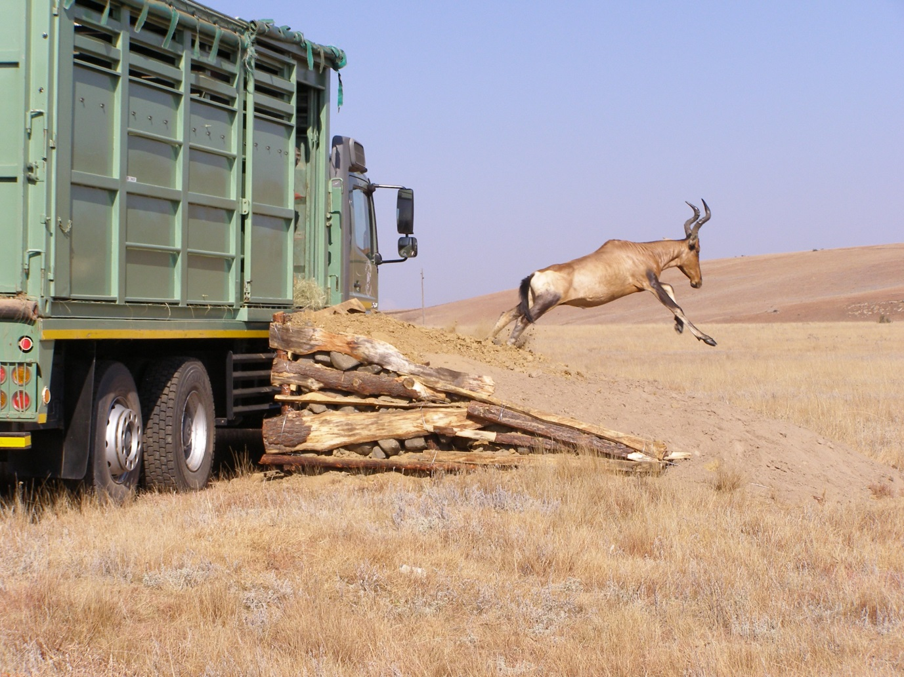
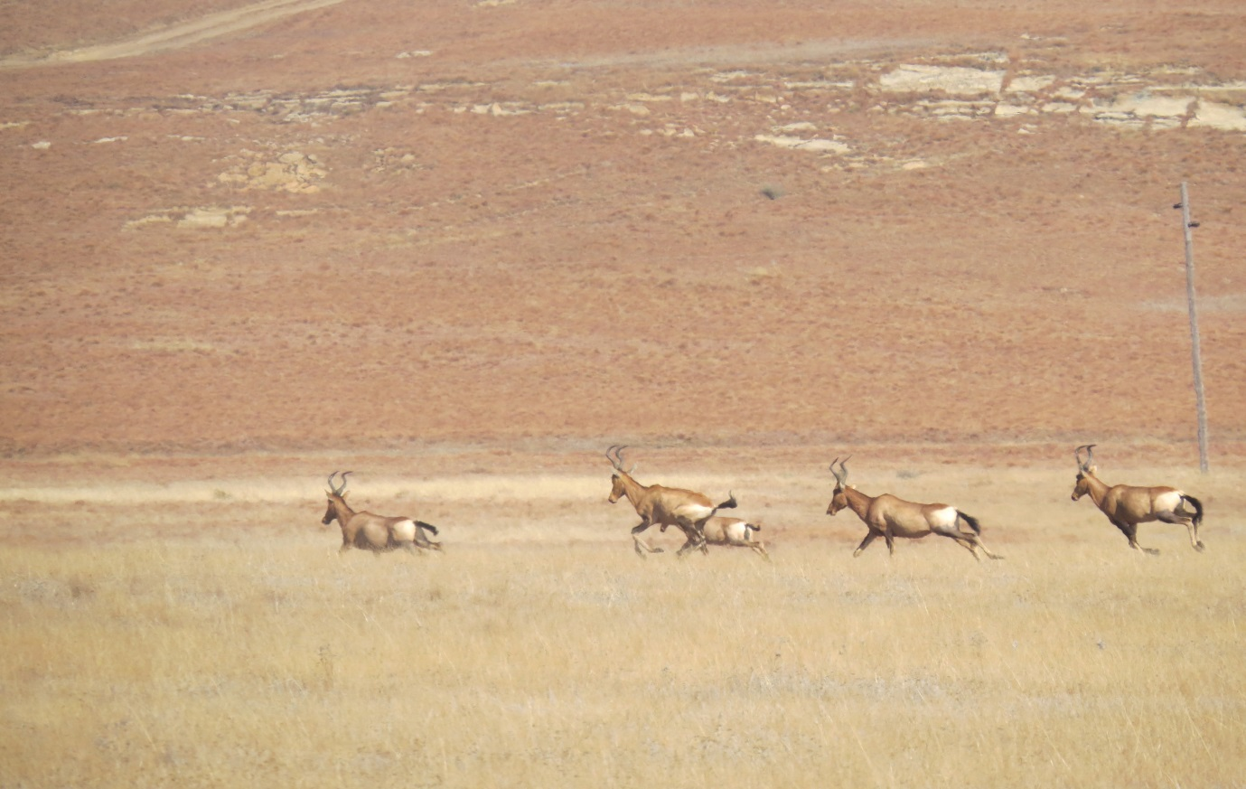

The delivered Red Hartebeest enjoying their new home

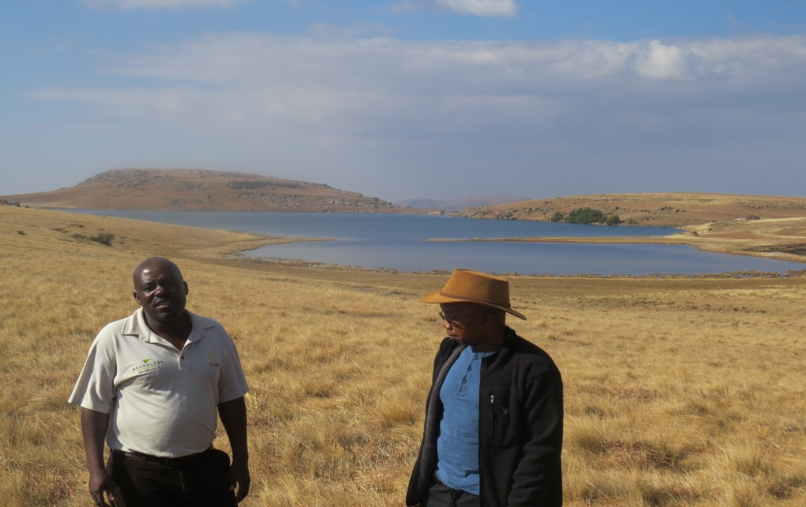

MDTP Coordinator Mr Rabson Dhlodhlo with Matatiele Environmental Manager Mr Thando Msomi at the Mountain Lake

