African Responsible Tourism Awards
MEDIA RELEASE: Thursday 16 November, Cape Town
Gansbaai takes the Gold at the African Responsible Tourism Awards 2015
A community of tourism businesses working together to make better places to live in and great places to visit was announced Overall Winners this afternoon at the African Responsible Tourism Awards 2015 in Cape Town, sponsored by Wesgro.
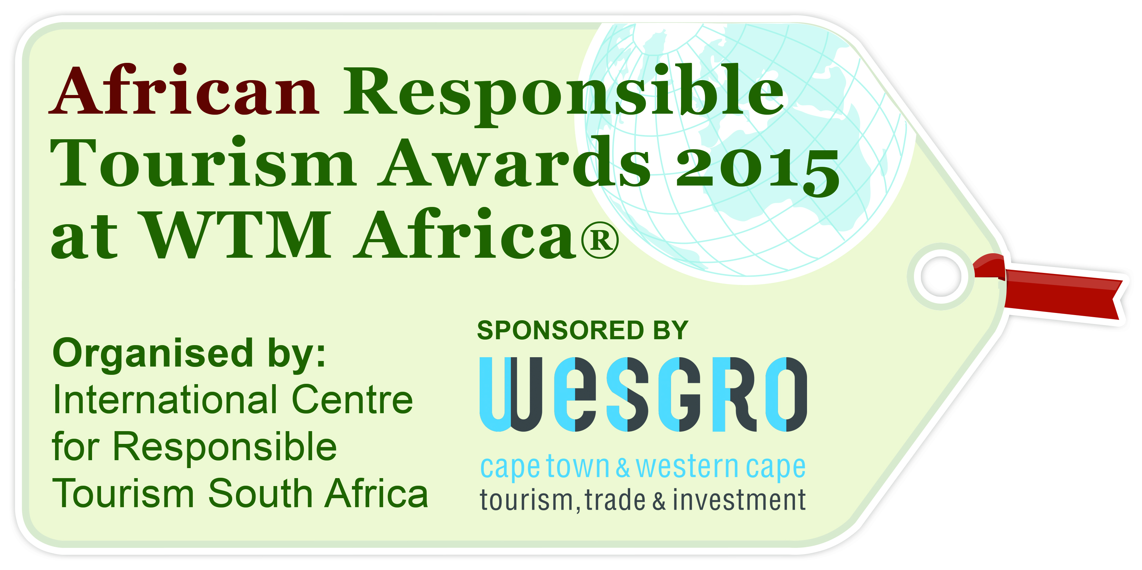
In a special ceremony at World Travel Market Africa, Gansbaai took the coveted position of Overall Winner from of a selection of 22 finalists gathered from around Africa.
“It is exciting to bring the Word Responsible Tourism Awards family of the Awards to Cape Town & Africa” says Harold Goodwin, Chair of the Judging Panel. “There are many world class winners being announced today. Since 2004 African businesses from 14 countries have won awards, 20% of the Awards winners have been from Africa, 20% of all of those awarded. “
Speaking before a packed audience of over 100 tourism professionals, media, ministers and officials, Heidi van der Watt, managing director of Better Tourism Africa pinpointed what makes the Award winners the leaders in responsible tourism in Africa:
“Our winners have a vision that extends beyond the commercial – linking business success with the wellbeing of local communities and the longevity of their environments. They want to make profits with principles, communicate balance sheets alongside beliefs, and won’t undermine passion in the pursuit of professionalism. They are resilient, determined, humanising advocates for their destinations. They are the future of tourism in Africa.”
The Awards were sponsored by the Wesgro. Tim Harris, Chief Executive Officer of Wesgro, who handed out the Awards, said:
“As the proud headline sponsor of the inaugural African Responsible Tourism Awards, Wesgro is delighted to pay tribute to this year’s inspirational winners. As the official Tourism, Trade and Investment Promotion agency for Cape Town and the Western Cape, we continue to show our commitment to responsible tourism development both in our province and on the African continent.
We are pleased to recognise the vision of the Award winners for providing leadership in their respective sectors throughout Africa, and effectively contributing to growing tourism in a sustainable manner.”
Read below for the full list of this year’s winners.
1. Overall Winner - sponsored by Wesgro
Gansbaai www.gansbaaiinfo.com @GansbaaiTourism
Contact: Brenda du Toit, Brenda1dutoit@gmail.com
Judges’ reasons for winning: “This is a remarkable group of tourism businesses many of which have won Responsible Tourism Awards individually, including Grootbos for its conservation of the fynbos and its poverty reduction impact, and Marine Dynamics for conservation and local economic development. The judges want to recognise them for the overall award for the way in which they have worked, together to create a destination, with outstanding product, memorable experiences and brought local economic development and communal facilities to the local community. They have demonstrated what tourism can do to make better places to live in and great places to visit.”
2. Best for Beach Tourism - supported by BulkSMS and Shark Spotters
Gold Winner:
Chumbe Island Coral Park www.chumbeisland.com @ChumbeIsland
Contact: Kevin Macdonald, chumbe@zitec.org
Judges’ reasons for winning: “Chumbe was highly commended for water conservation in the World Responsible Tourism Awards in 2013 and they won the marine environment category in 2004. This time the judges wanted to recognise them for their careful review of progress to 2006 and the development of the new Management Plan 2006-2016. The judges saw this as an example of good practice and one which others should emulate.”
Silver Winner: Nuarro Lodge @Nuarro
Contact: Kim Rossi, reservations@nuarro.com, www.nuarro.com/en/
3. Best Blog for Responsible Tourism - sponsored by Cape Town Tourism
Gold Winner: The Good Holiday http://thegoodholiday.com/
Contact: Dee Lourens, dee@thegoodholiday.com @the_goodholiday
Judges' reasons for winning: “The Good Holiday has authenticity, a real sense of care and a true desire to facilitate experiences that are beneficial to all it comes in contact with at the heart of stories told. Interactive and visually appealing, the blog inspires travellers to journey to African places with a unique cultural heritage, places that inspire people to consider a life seeking simple pleasures that tread lightly on the earth.
Silver winner: My Slow Journey http://myslowjourney.com/
Contact: Katarina Mancama, k.mancama@gmail.com, @KatarinaMancama
4. Best Destination for Responsible Tourism, sponsored by the V&A Waterfront
Gold Winner: Gansbaai www.gansbaaiinfo.com @GansbaaiTourism
Judges' reasons for winning: “Since 1995 Gansbaai Tourism has worked to create awareness of and market the area as a tourism destination. The cluster of businesses in the area, some of them with international reputations, have worked together to develop an exemplary destination, a quality guest experience which has conserved fynbos and marine wildlife, created significant direct and indirect employment and they are now working together to quantify their environmental impacts.
Contact: Brenda du Toit, Brenda1dutoit@gmail.com
Silver Winners:
- Bigodo Wetlands Sanctuary http://www.bigodi-tourism.org/6601.html
Contact: Tinka John, tinkabigodi@gmail.com
- Cape Town www.responsiblecapetown.co.za @RespCPT
Contact: Nombulelo Mkefa, nombulelo.mkefa@capetown.gov.za
5. Best for engaging people and cultures, sponsored by Gauteng Tourism Authority
Gold Winner: Coffeebeans Routes, Cape Town, South Africa http://coffeebeansroutes.com/ @coffeebeansrout
Contact: Iain Harris, iain@coffeebeansroutes.com,
Judges' reasons for winning: “Setting an example that could be replicated in other destinations, Cape Town-based Coffeebeans Routes creates travel experiences around urban stories. These are contemporary, urban, African experiences that provide deep insights, and plenty of fun. The experiences bring visitors and locals together across boundaries. Unapologetic about pushing social justice agenda, Coffeebeans Routes employs tourism as a tool to unlock economic potential and address societal inequalities through exploring cultural diversity and legacy.”
Silver Winners:
- !Khwa ttu San Culture and Education Centre @KhwattuSan
Contact: Michael Daiber, michael@khwattu.org, www.khwattu.org
- Nkwichi Lodge @nkwichi
Contact: Kim Rossi, info@nkwichi.com, www.nkwichi.com
- TFPD Foundation, for the work done at Baleni Camp @TFPD_SA
Contact: Eleanor Muller, Eleanor@tfpd.co.za, www.africanivoryroute.co.za
6. Best for Poverty Reduction, sponsored by Marine Dynamics
Joint Gold Winner:
Grootbos Private Nature Reserve in partnership with the Grootbos Foundation www.grootbosfoundation.org @GrootbosNGOZA
Contact: Julie Cheetham, julie@grootbosfoundation.org
Transfrontier Parks Destinations www.tfpd.co.za @TFPD_SA
Contact: Eleanor Muller, Eleanor@tfpd.co.za
Judges' reasons for winning: ”Here we have two winners working at different scales – each in their own way using tourism as a vehicle for poverty reduction.
Grootbos is no stranger to winning Responsible Tourism Awards. What stands out is the long history of interventions that amplify each other. The programmes of the Grootbos Foundation focus on improved livelihoods through self-reliance, development of viable enterprise development, gender balance and empowerment of women. Impacts are well quantified and information about projects easily accessible to the willing reader.
The scale and ambition of the Transfrontier Parks Destination’s work is truly remarkable. To actively seek out failing tourism businesses in areas of very high unemployment is very admirable but to them turn them round into viable businesses again employing many locals on a living wage giving them long term stability and income displays true leadership.”
Silver Winner:
Stormsriver Adventures www.stormsriver.com @Tsitsikamma
Contact: Anneline Wyatt, anneline@stormsriver.com
7. Best for resource management, supported by the National Cleaner Production Centre of South Africa
Gold Winner: Chobe Game Lodge, Botswana www.chobegamelodge.co.bw @chobegamelodge
Contact: Johan Bruwer, johan.bruwer@chobegamelodge.co.bw
Judges' reasons for winning: “Chobe Game Lodge is over 40 years old, to refurbish an old structure the size of this lodge, making it more eco-friendly is a mammoth and on-going task. The lodge has a long term approach to energy efficiency with the ultimate aim of reducing dependency on the grid. The most noticeable innovation is the use of All Electric Game Drive Vehicles and Electric game viewing boats.
Silver Winners:
- Hoanib Skeleton Coast Camp www.wilderness-safaris.com @WeAreWilderness
Contact: Sue van Winsen, SueW@wilderness-safaris.com

- Sandele Eco-Retreat and Learning Centre www.sandele.com
Contact: Maurice Phillips, maurice@sandele.com
- Table Mountain Aerial Cableway Company www.tablemountain.net @TableMountainCa
Contact: Collette van Aswegen, collette@tablemountain.net
- Vineyard Hotel www.vineyard.co.za @Vineyard_Hotel
Contact: Chris van Zyl, hotel@vineyard.co.za
8. Best for Wildlife Conservation, sponsored by South African National Parks
Gold Winner: Marine Dynamics, South Africa www.sharkwatchsa.com @Marine_Dynamics
Contact: Brenda du Toit, apss@dict.org.za
Judges’ reasons for winning: “Marine Dynamics provide very high quality shark cage diving experiences. They operate in a sector where there is rightly a lot of criticism of current practice. Marine Dynamics are industry leaders, a commercial operation which operates to the highest conservation standards, where every trip has a marine biologist aboard to provide interpretation and collect data for scientific research. An operator that makes a significant contribution to conservation and the local economy.
Silver Winner:
- andBeyond’s Rhinos Without Borders www.andbeyond.com/conservation-community/rhinos-without-borders.htm
Contact: Valeri Mouton, valeri.mouton@andbeyond.com
- Bartholomeus Klip Farmhouse www.bartholomeusklip.com
Contact: Lesley Gillett, bartholomeus@icon.co.za
- Ends -
_________________________________________________________________________________
Notes to editors
High resolution jpg images of logos and interviews available upon request.
About the awards
For more information on the African Responsible Tourism Awards visit www.africanresponsibletourismawards.com
The African Responsible Tourism Awards celebrate the most inspiring stories in responsible tourism on the African continent and showcase tourism organisations which are, actively and demonstrably, taking responsibility for making tourism stronger. The first African Responsible Tourism Awards is a regional programme, which with the Irish Responsible Tourism Awards form part of the World Responsible Tourism Awards family. The World Responsible Tourism Awards, founded in 2004 by Responsible Travel and now in their 12th year are presented at WTM in London on World Responsible Tourism Day.
The awards are organised by Better Tourism Africa (formerly International Center for Responsible Tourism - South Africa), in partnership with Responsible Travel.
The awards ceremony is hosted by World Travel Market Africa. Winners in the African awards will automatically qualify for the World Responsible Tourism Awards.
Note to editors
For media enquires information contact:
Better Tourism Africa
Jacques Maritz
Email: Jmps@worldonline.co.za
Tel: +27 (0)83 389 2523
Website: www.africanresponsibletourismawards.com
About Better Tourism Africa
Better Tourism Africa - a non-profit company established in 2006 - works alongside government, the private sector and communities in Africa to implement the objectives of Responsible Tourism as described in the Cape Town Declaration. We believe tourism should be harnessed to create better places for people to live and to visit. Our work includes advocacy, training and capacity-building, research and technical advisory services. For more information, visit www.bettertourismafrica.org
About Wesgro
The Western Cape is a region of unlimited potential, and this translates into unlimited opportunity. Whether you’re interested in travel, business or export, Cape Town and the Western Cape has something for you. Let Wesgro, the official tourism, trade and investment promotion agency for Cape Town and the Western Cape, help you uncover the opportunities. For more information, visit www.wesgro.co.za
About World Travel Market Africa
World Travel Market Africa is a must attend business-to-business travel and tourism event, that in 2014, boasted 370 exhibitors, 476 Buyers, 2132 trade visitors and attracted over 3091 industry professionals from over 60 countries around the world. www.wtmafrica.com
World Travel Market Africa is part of Reed Travel Exhibition’s WTM portfolio, which also includes World Travel Market, World Travel Market Latin America and Arabian Travel Market. www.wtmworld.com
About Responsible Travel:
Responsible Travel is the world’s leading market place for small and tailor-made tour operators, all screened for their commitment to responsible tourism.
Responsible Travel connects these operators with people looking for real & authentic holidays. Starting with just two tour operators in 2001, Responsible Travel has become the leading place to find tours from over 400 small and specialist tour companies in 197 countries. As tourism grows globally the opportunity for authentic experiences diminishes, and the impacts of tourism on places and local people (not always positive) grows. We’ve found the secret to authentic travel is treating local people and places responsibly.
In addition, Responsible Travel
- campaigns for positive change in the travel and tourism industry.
- publishes an expanding collection of open, honest travel guides
CEO Justin Francis has been included in Courvoisier’s The Future 500, Thames and Hudson’s 60 Innovators Shaping Our Creative Future and taken his place on the Advisory Board of The International Centre for Responsible Tourism.
The company is based in Brighton's North Laine district, England.

