PROJECT PROGRESS REPORT

1.PROJECT DETAILS

Project Name : EC – Matatiele Nature Reserve Gateway Office and Eco-Tourism
Complex

Implementer : Farci Trading cc

Project Duration : 12 months

2. PROJECT DESCRIPTION

The project is aimed at constructing the administration facility for conservation and ecotourism functions of the municipality. The project will encompass Administration Block and Art Craft retail & display area with kiosk, guests & personnel ablutions facilities, parking area, pathways, fencing and re-vegetation.

3. PROJECT BUDGET

The approved project budget is R 7,000,000.00

4. DELIVERABLES

Deliverable 1 : | Pedestrian Walkway
Deliverable 2 : | Sewer Reticulation
Deliverable 3 : | Parking Bays
Deliverable 4 : | Water Reticulation
Deliverable 5 : | Administration Block & Art Centre
Deliverable 6 : | Fencing
Deliverable 7 : | Guard House
Deliverable 8 : | Re-vegetation and Landscaping

5. JOB CREATION

Category | Planned No. of people | Rate | No of people employed to date
Clerical | 2 | R 123.00 | 2
Labourers | 77 | R 82.00 | 36
Semi-skilled | 6 | R 103.00 | 6
Skilled | 4 | R 123.00 | 4
Supervisors | 2 | R 144.00 | 2
TOTAL | 82 |  | 50

*** Initially project employed all 82 beneficiaries but due to the delays and works being
on hold some beneficiaries have not reported to work yet. Only 50 have reported
back to work; some advised that they will be available from Monday, 01 February 2015
whilst others have resigned. We are busy with replacing them.

6. SKILLS DEVELOPMENT

The following non-accredited training courses have been conducted:

Courses | No. of Trainees
First Aid | 20
Health & Safety | 82
Life Skills | 82
Environmental Awareness | 82
Personal Finance | 82
HIV/AIDS | 82

8. PROGRESS TO DATE

- Site Clearance is 100% complete
- Administration Block and Arts Craft Centre: Excavations are 100% complete
- Guard House: Foundations are 100% complete; Superstructure is 50% complete
- Water reticulation: Drilling and installation of borehole is 90%
- Fencing: Site clearance and Digging of holes is 100% complete; Installation is 55%
Complete

7. PHOTOS SHOWING CURRENT PROGRESS

- Fencing – Welded Mesh

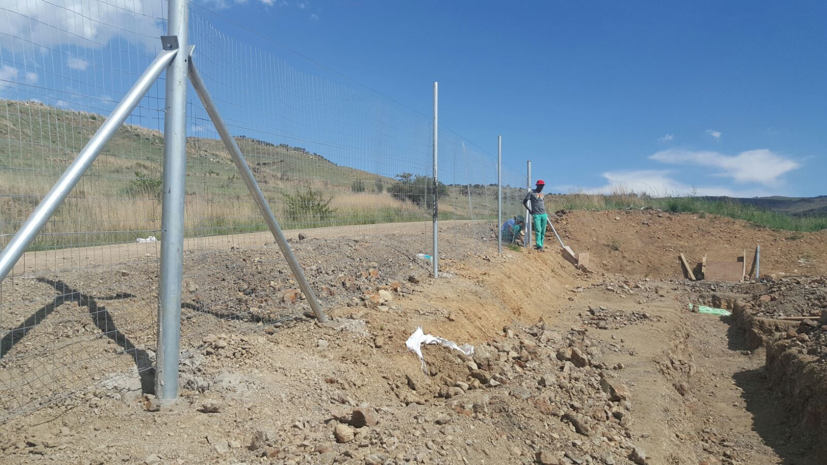

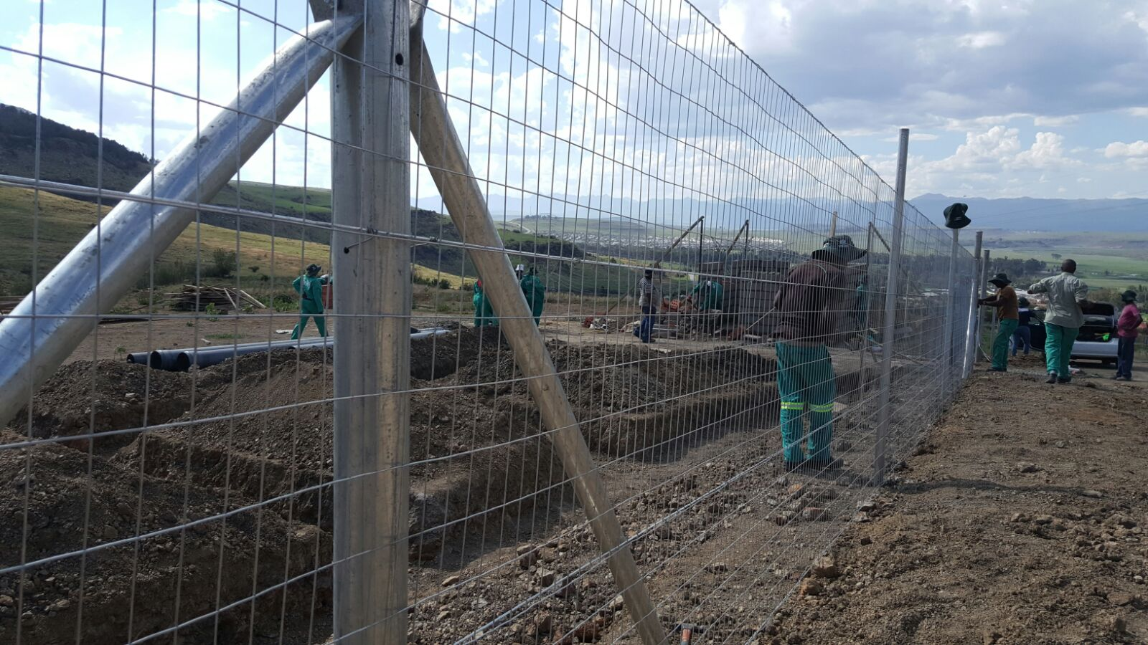

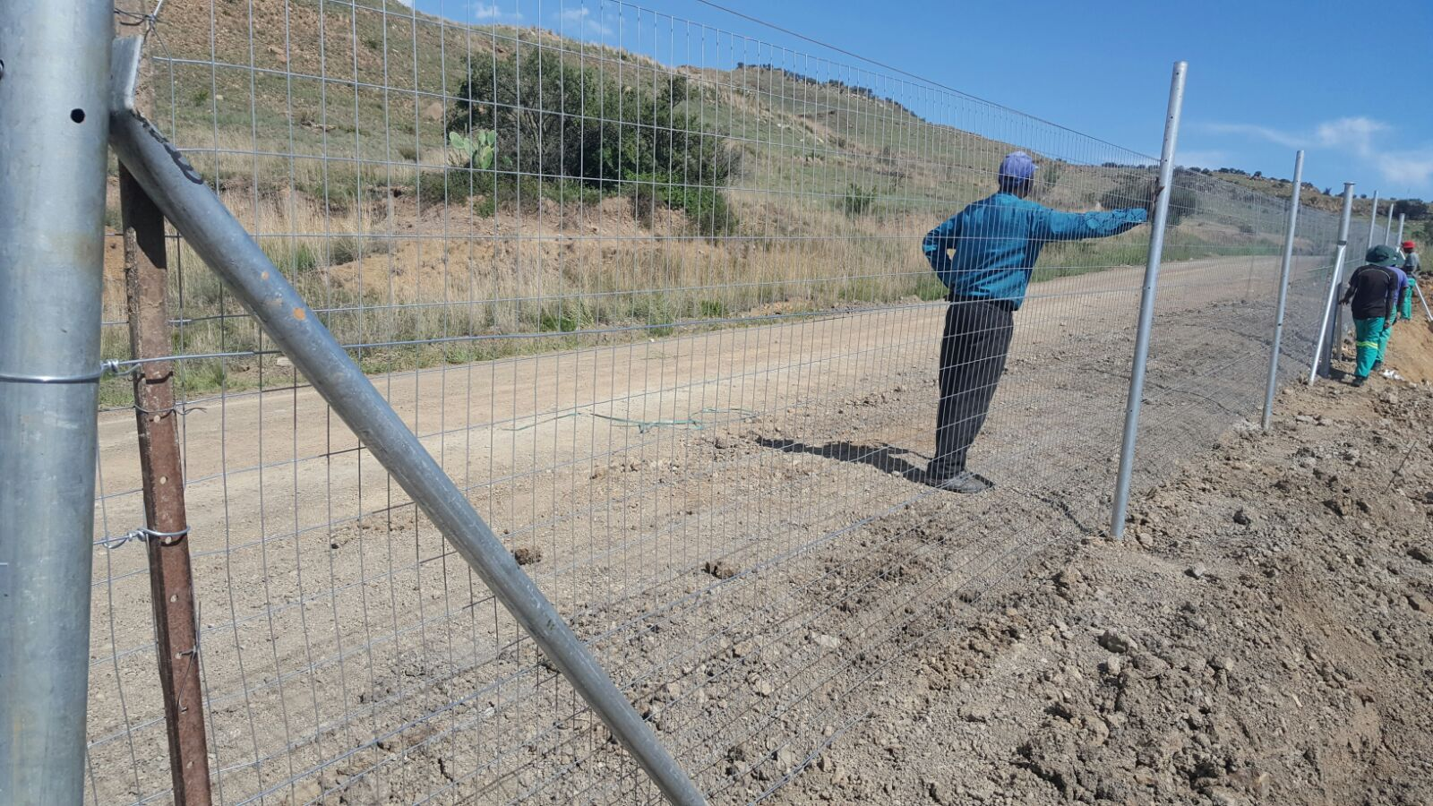
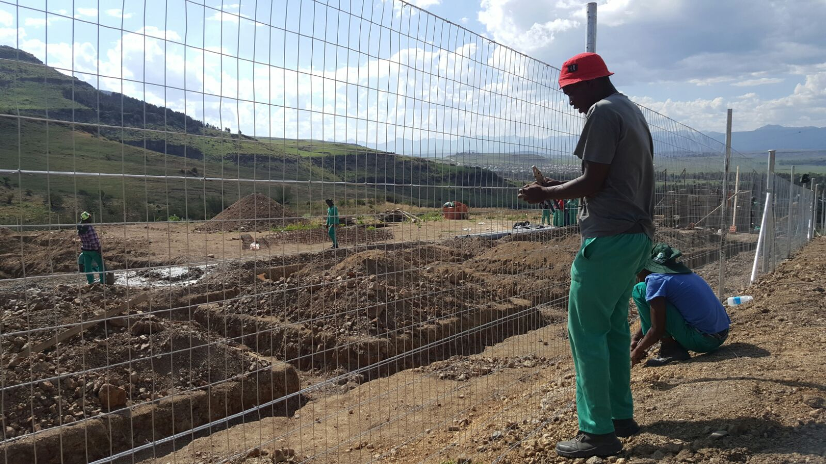

- Guard House

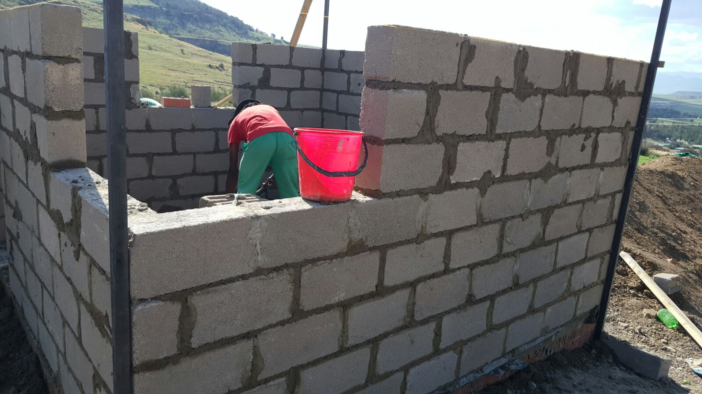

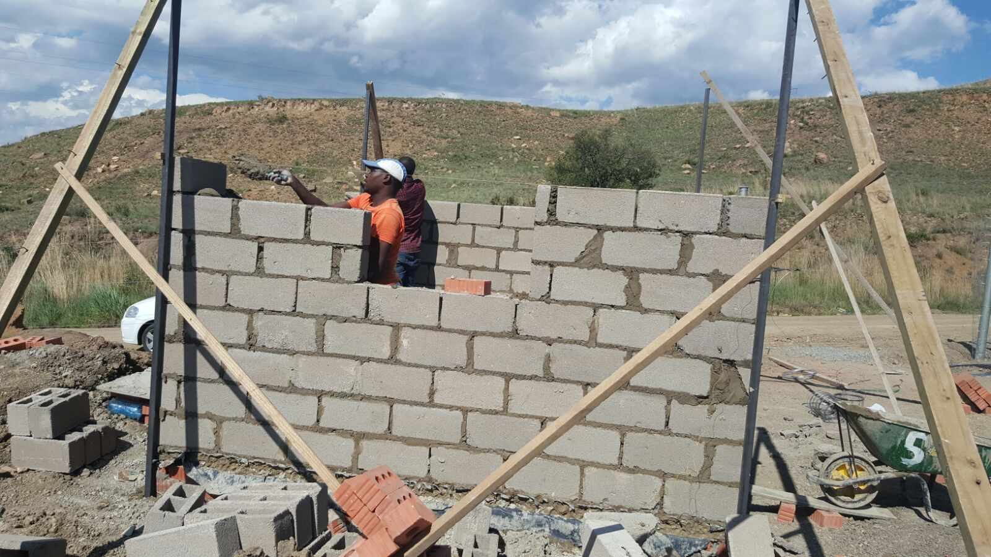
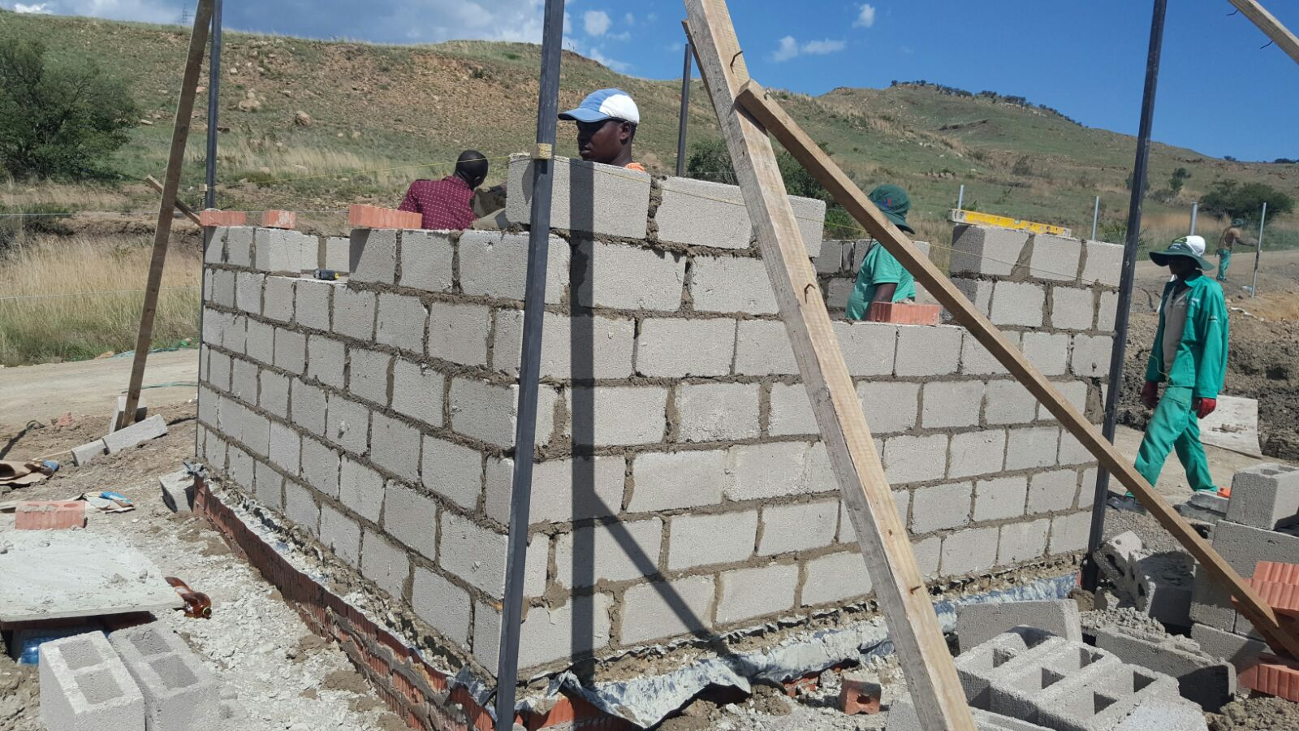

- Admin Block and Arts Craft Centre – Excavations for foundations and Fencing

